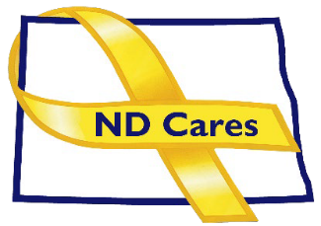

AGENDA

ND CARES COALITION MEETING (VIRTUAL)
June 4, 2026, 1:00 AM – 3:00 PM
To join via Microsoft Teams
To join by phone: 701-328-0650, Conference ID: 583 559 407#

WELCOME: Todd Remington

COALITION MEMBER UPDATES (ALL)

ADMINISTRATIVE UPDATE
  - ND Cares Business Update: 30
  - ND Cares Community Update: 61
  - Strategic Plan Update (NDBA)
  - Governor’s Challenge Update

UPCOMING EVENTS –
- FirstLink Trainings
- Star Behavioral Health Providers Training
- ND Brain Injury Network Events
- Vets for Vets Minot Events
- Military Couples Relationship Retreat: Grand Forks June 12-14
- Native American Veterans Stand Down: June 10-11, Fort Yates
- Turtle Mountain Vets in the Park: June 14, Skydancer Casino Parking Lot, Belcourt
- VisionWest Summit on Behavioral Health in Energy Country: June 17-18, Dickinson
- CALM Conversations Workshop: Virtual June 9, Register here
- Safety Planning Workshop: Virtual June 15, Register here
- Vet Fest: June 17, Fargo
- RedHawks Military Appreciation Night: June 24
- Larks Military Appreciation Day: June 27, Bismarck
- Medora Musical Military Appreciation Day: July 12, Medora
- CALM Clinical Workshop: Virtual Sept. 3, Register here
- Dickinson Area Stand Down, Sept 16, Dickinson
- NDHHS Behavioral Health Conference: Sept 14-17, Bismarck
- Grand Forks Vets in the Park: Aug 14, University Park, Grand Forks
- Veterans Stand Down: Aug 20, AMVETS, Bismark
- Military Day at the State Fair: Aug 21, Minot
- Veterans Stand Down: Oct 15, Armed Forces Reserve Center

NEXT MEETING DATES
  - Coalition Mtgs 2026: Sept. 3, Dec. 3 from 1:00-3:00 pm
  - Executive Committee Mtg 2026: Jul. 2, Aug. 6, Oct. 1, Nov. 5 from 10:30-Noon.

