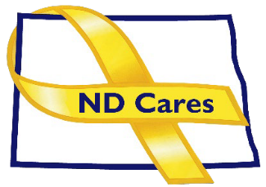

AGENDA

ND CARES EXECUTIVE COMMITTEE MEETING (VIRTUAL)
July 2, 2026, 10:30 AM – 12:00 PM
To join via Microsoft Teams
To join by phone: 701-328-0950, Conference ID: 461 079 705#

OPENING
  - Comments (Todd)
  - Approve the Executive Committee meeting minutes from May 14, 2026.

NEW BUSINESS
  - Executive Committee Member Updates
    - Chair/Co-Chairperson
    - ND DVA
    - Regional VA, Fargo
    - ND Dept. of Health & Human Services, Health Division
    - ND Dept. of Health & Human & Services, Behavioral Health Division
    - ND National Guard
    - Army Reserve Ambassador for North Dakota

OLD BUSINES
  - ND Cares Business Update: 30
  - ND Cares Community Update: 61
  - Strategic Plan Update (NDBA)
  - Governor’s Challenge Update
  - Budget

UPCOMING EVENTS –
- FirstLink Trainings
- Star Behavioral Health Providers Training
- ND Brain Injury Network Events
- Vets for Vets Minot Events
- Medora Musical Military Appreciation Day: July 12, Medora
- Military Day at the State Fair: July 21, Minot
- Grand Forks Vets in the Park: Aug 14, University Park, Grand Forks
- Veterans Stand Down: Aug 20, AMVETS, Bismarck
- CALM Clinical Workshop: Virtual Sept. 3, Register here
- CALM Conversations Workshop: Virtual Sept 14, Register here
- NDHHS Behavioral Health Conference: Sept 14-17, Bismarck
- Dickinson Area Stand Down: Sept 16, Dickinson
- Safety Planning Workshop: Virtual Sept 17, Register here
- ACOVA: Sept. 17-18, Fargo
- Military Couples Relationship Retreat: Sept 25-27, Grand Forks
- Together with Veterans Veteran Suicide Prevention Symposium: Sept. 28, Minot
- Veterans Stand Down: Oct 15, Armed Forces Reserve Center

NEXT MEETING DATES
  - Coalition Mtgs 2026: Sept. 3, Dec. 3 from 1:00-3:00 pm
  - Executive Committee Mtg 2026: Aug. 6, Oct. 1, Nov. 5 from 10:30-Noon.

