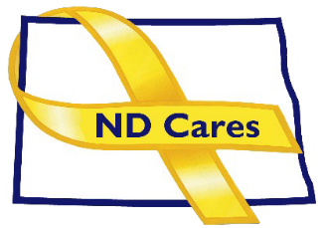

AGENDA

ND CARES EXECUTIVE COMMITTEE MEETING (VIRTUAL)
May 14, 2026, 10:30 AM – 12:00 PM
To join via Microsoft Teams
To join by phone: 701-328-0650, Conference ID: 337 754 534#

OPENING
  - Comments (Todd)
  - Approve the Executive Committee meeting minutes from April 2, 2026.

NEW BUSINESS
  - Executive Committee Member Updates
    - Chair/Co-Chairperson
    - ND DVA
    - Regional VA, Fargo
    - ND Dept. of Health & Human Services, Health Division
    - ND Dept. of Health & Human & Services, Behavioral Health Division
    - ND National Guard
    - Army Reserve Ambassador for North Dakota

OLD BUSINES
  - ND Cares Business Update: 30
  - ND Cares Community Update: 61
  - Strategic Plan Update (NDBA)
  - Governor’s Challenge Update
  - ADA Compliance

UPCOMING EVENTS –
- FirstLink Trainings
- Star Behavioral Health Providers Training
- ND Brain Injury Network Events
- Vets for Vets Minot Events
- Military Couples Relationship Retreat: Grand Forks June 12-14
- CALM Clinical Workshop: Virtual June 2, Register here
- Native American Veterans Stand Down: June 10-11, Fort Yates
- CALM Conversations Workshop: Virtual June 9, Register here
- Safety Planning Workshop: Virtual June 15, Register here
- Vet Fest: June 17, Fargo
- Dickinson Area Stand Down, Sept 16, Dickinson

NEXT MEETING DATES
  - Coalition Mtgs 2026: Jun. 4, Sept. 3, Dec. 3 from 1:00-3:00 pm
  - Executive Committee Mtg 2026: Jul. 2, Aug. 6, Oct. 1, Nov. 5 from 10:30-Noon.

