COALITION MEETING AGENDA
1:00 pm – 4:30 pm, May 9th, 2019
RJB Armory Room #387, 4200 Miriam Ave, Bismarck, ND
The dial in number for the meeting is: 1-855-509-2650; passcode: 32015#
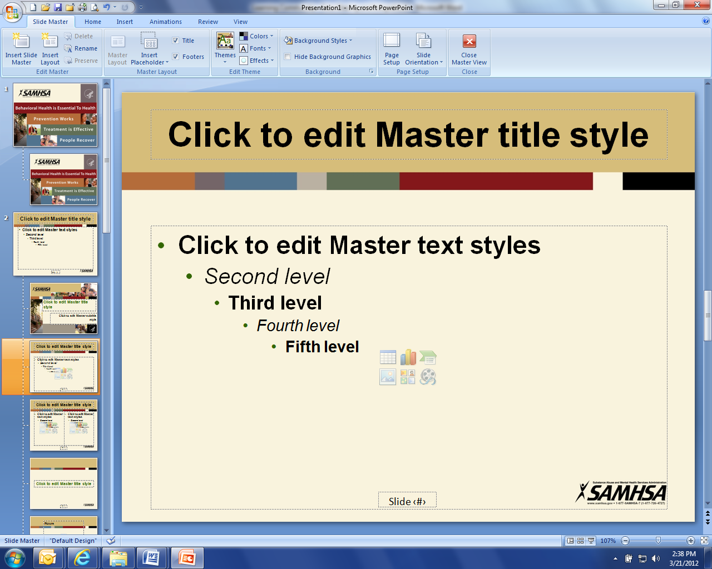
1:00 pm Welcome and Introductions (Connie)

1:10 pm Legislative Initiatives Updates
- Rebecca Quinn – TBI Network
- Pam Mack – Protection and Advocacy
- Lisa Peterson – Department of Corrections and Rehabilitation
- Pam Sagness – Behavioral Health Division
- Lonnie Wangen – ND Department of Veterans Affairs
- Major General Dohrmann – ND National Guard

2:30 pm Break

2:45 pm Coalition member updates (All)

3:30 pm Staff Update: (Darcie and Joe)
- Strategic Plan and metrics
- Community Program
- Website, Newsletter and Tele-conferences
- Business Initiative
- Regional training
- Budget
- Future Coalition meeting dates?
- Due outs from meeting

4:15 pm Upcoming events: (Darcie)
- Executive Committee Meetings, telephone, June 19th, August 21st
- ACOVA, Steele, May 23-24, 2019
- Region V ND Cares Community Training, West Fargo, May 22nd, 2019
- ACOVA, Bismarck, August 15-16, 2019
- Fargo VA Community Mental Health Summit, Minot, August 22nd, 2019
- Remembrance Weekend, Mandan, August 9-10

4:25 pm Closing (Connie)

