COALITION MEETING AGENDA
10:00 am – 2:30 pm, November 25th, 2019
RJB Armory Room #393, 4200 Miriam Ave, Bismarck, ND
NO DIAL-IN FOR THIS MEETING
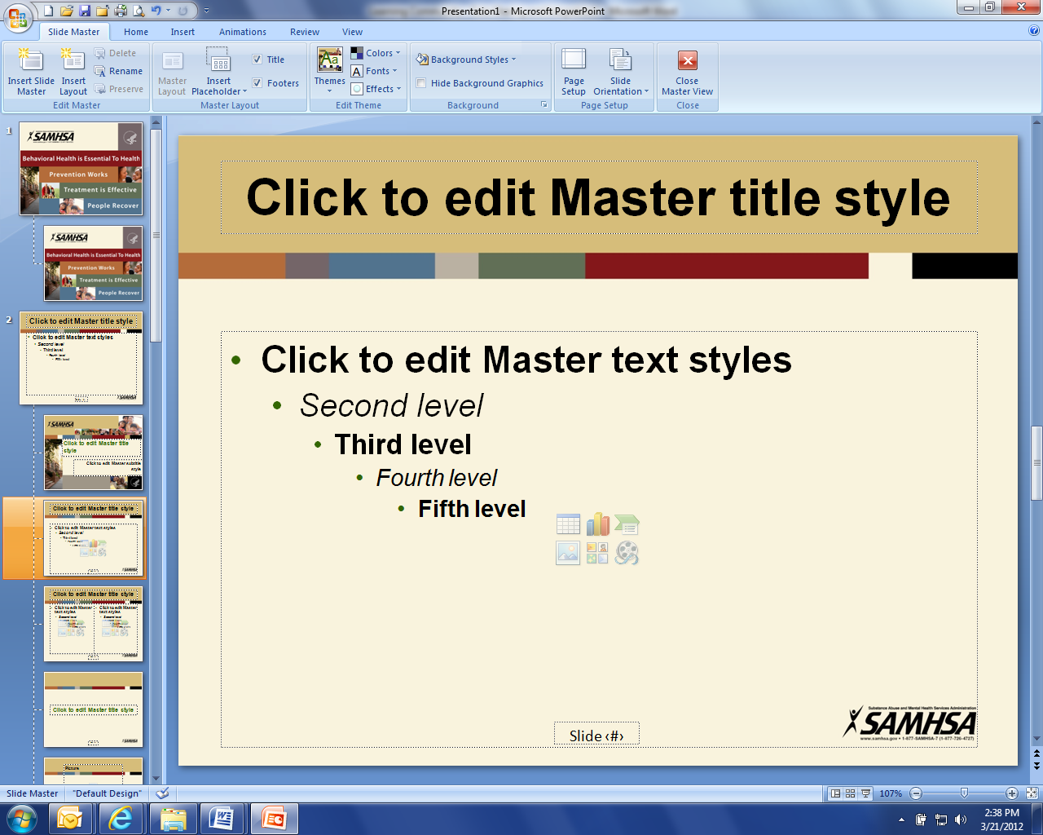
10:00 am Welcome and Introductions (Connie)

10:05 am Facilitated Discussion/Planning

12:00 pm Pause for Lunch

12:15 pm Continue Facilitated Discussion Planning

2:00 pm Review of Planning Products

2:30 pm Closing Comments (Connie)

**Break as needed or determined by Chairperson

