COALITION MEETING AGENDA
1:00 pm – 4:30 pm, September 12th, 2019
RJB Armory Room #387, 4200 Miriam Ave, Bismarck, ND
The dial in number for the meeting is: 1-701-333-2840; conference id & passcode: 32015#
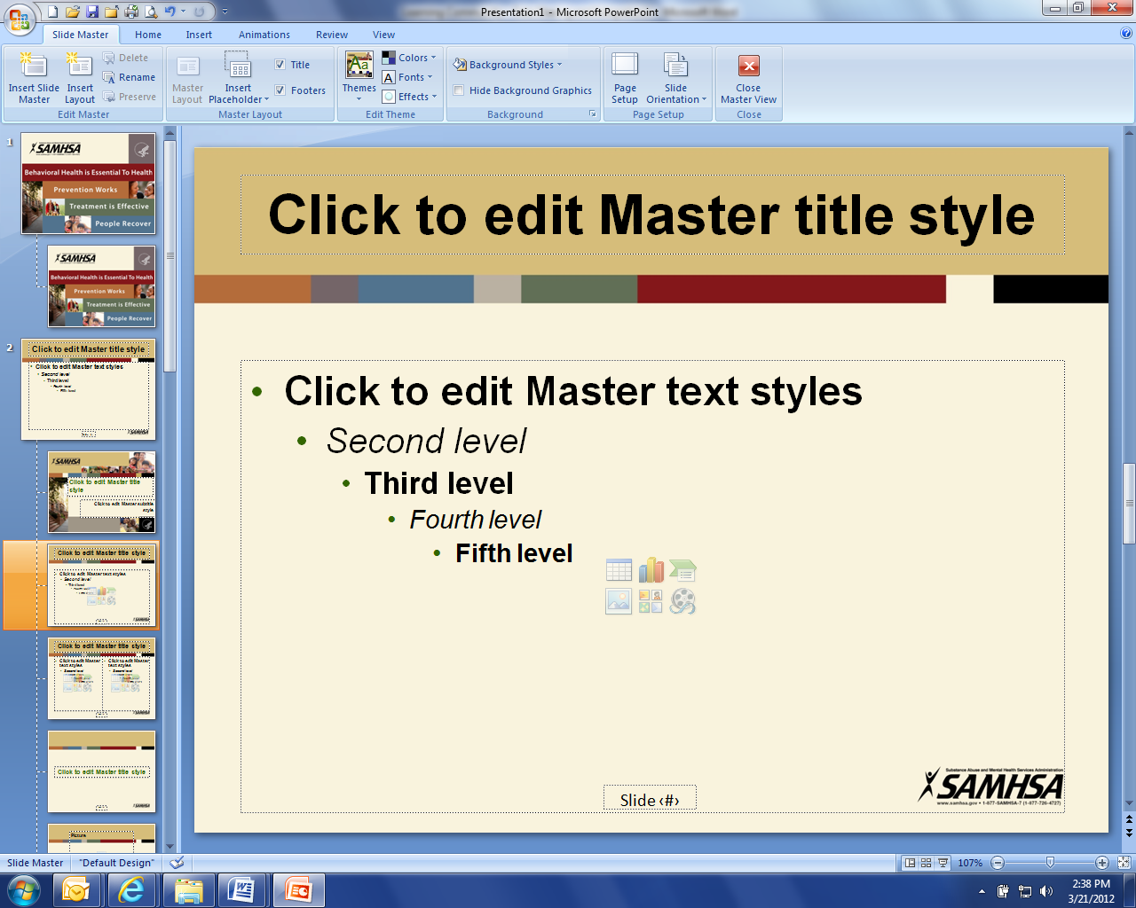
1:00 pm Welcome and Introductions (Connie)

1:05 pm Interactive Discussion Topics (All)
ND Dept of VA – Grants program overview
Mission Act Overview – David Francavilla
Community Clergy Training Program – David Francavilla
Strat Plan Considerations/Review/Update
Long term relationship with Psych Armor Institute
Training for providers on Tricare and the Mission Act
Veteran’s Court (ND DVA)
Peer-to-Peer Program
KAT advertising proposal
ND Suicide Prevention Coalition
Behavioral Health Conference

2:30 pm Break

2:45 pm Coalition member updates (All)

3:30 pm Staff Update (Darcie)

4:15 pm Upcoming events (Darcie)

4:25 pm Closing (Connie)

