COALITION MEETING AGENDA
12:30 pm – 3:00 pm, July 9, 2020
VIRTUAL MEETING via Microsoft Teams
Join the Meeting Here
The dial in number for the meeting is: 1-701-328-0950; ID 698 808 83#
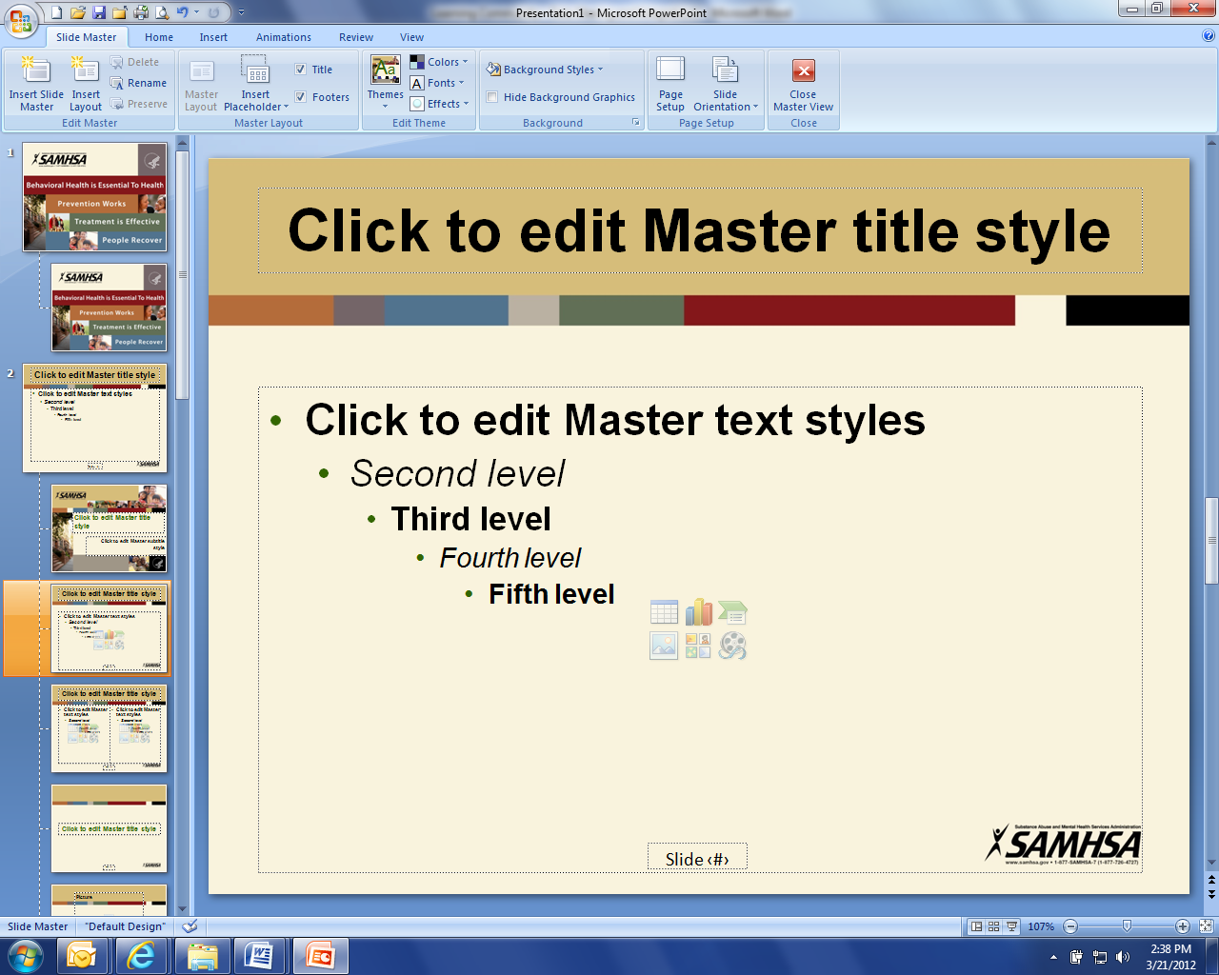
12:30 pm Welcome and Introductions (Connie)
12:35 pm Michelle Panos – Introduction and background.

12:40 pm North Dakota Suicide Prevention Coalition – Kora Dockter

1:00 pm North Dakota Brain Injury Network – Rebecca Quinn

1:20 pm Staff Update: (ED)
- Strategic Plan
- Broadcasters Association Contract – focus on reducing sigma
- Community & Business Program
- Website, Newsletter and Tele-conferences
- Budget and Donations
- Action Items from meeting

1:30 pm Break

1:40 pm Coalition member updates (All)

2:25 pm Upcoming events: (ED)
- Veteran Day, Medora – July 12
- Heroes Park Dedication, Bismarck – August 28
- Sept 11 Remembrance Day – Bismarck – September 11
- Gold Star Mother Award – Minot – September 11
- Disabled Veterans Deer Hunt, Camp Grafton – November 16-17

2:30 pm Closing (Connie)

