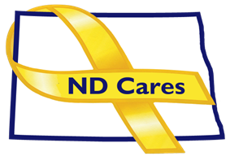
COALITION MEETING AGENDA
1:00 pm – 3:00 pm, Sept 5, 2024
Virtual meeting
Join the Virtual Meeting HERE, Call in number: 1-701-328-0950; passcode: 193 600 436#
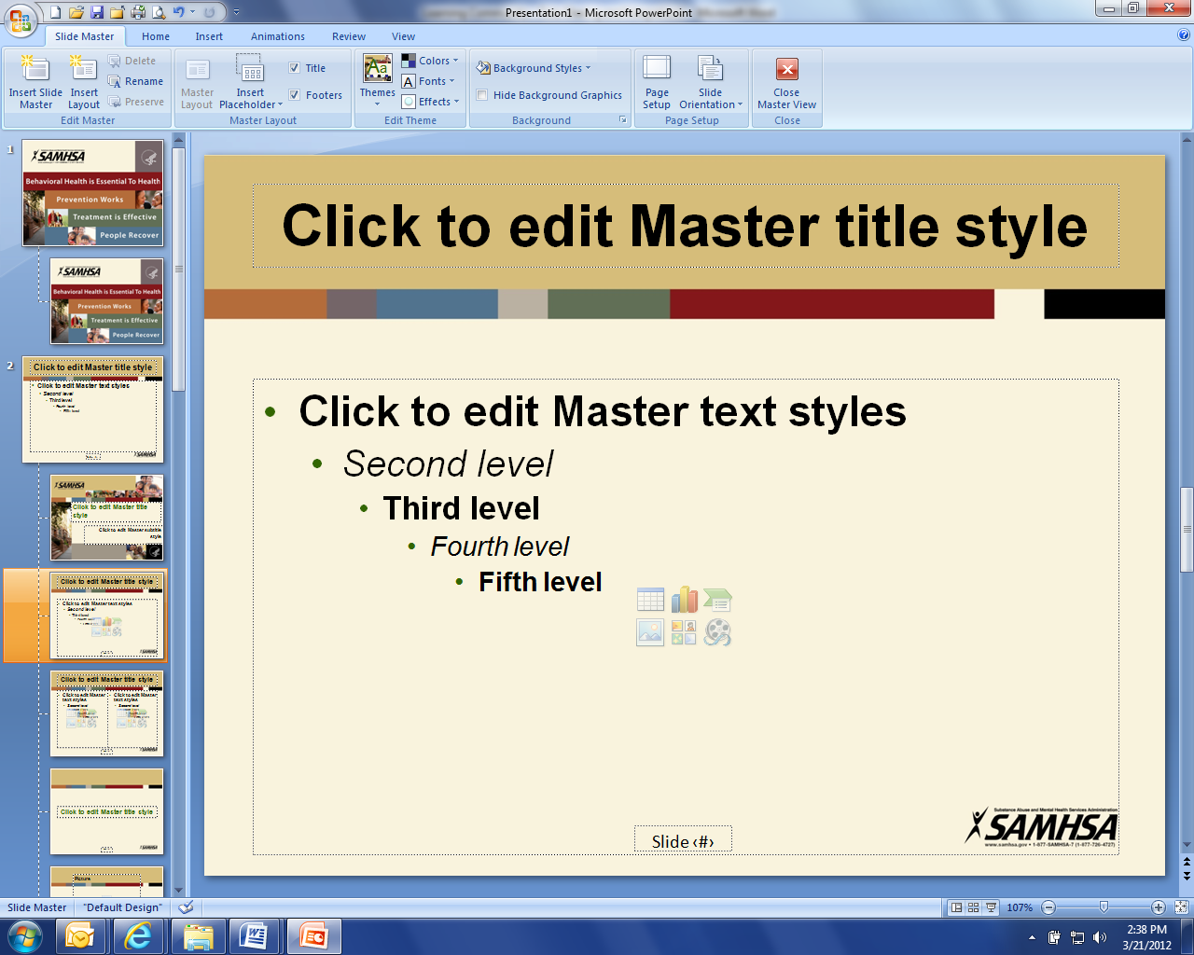
Welcome (Shelly/Cindy)
Coalition member updates (All)
Administrative Updates: (Michelle)
- Community Program - 58
- Business Initiative - 25
a. University of Jamestown, Legal Services of North Dakota, YMCA (Minot), NorthStar
- Strategic Plan
a. North Broadcasters Association PEPs
b. Governor’s Challenge Priority Areas Update
c. Data Book

Upcoming Events

- FirstLink Trainings
- Star Behavioral Health Providers Training
- ND Brain Injury Network Events
- Behavioral Health Conference: Sept 16-19, Bismarck Event Center (Virtual, In-Person)
- ND Suicide Prevention Coalition Conference: Sept. 5, Bismarck/Virtual
- YMCA Patriot Ruck: Sept 6, Minot, Check in at 8AM
- AFSP Out of the Darkness Walks: Sept 7-21 Williston, Dickinson, Watford City, Minot, Bismarck, Carrington, Devils Lake, Wahpeton
- 2024 Bakken Oil & Gas Mental Health awareness and Suicide Prevention Workshop: Sept. 17
- ACOVA Meeting: Sept. 19-20, Steele Veterans Club
- Documentary: Suicide – The Ripple Effect: Sept 24, Ann Nicole Nelson Hall, Minot State College
- Documentary: Suicide – The Ripple Effect: Sept 25, Kenmare Theater
- TWV Suicide Prevention Symposium: Sept. 30, Minot
- ND LGBTQIA2S+ Summit (Veteran Component): Oct. 11-13, Bismarck Event Center
- ND Hospital Association Annual Conference: Oct 15-17, West Fargo
- ND Hospital Association Trade Show: Oct 16, West Fargo
- North Central Veterans Stand Down: Oct 17, Armed Forces Reserve Center, Minot

NEXT MEETING DATES
- Coalition Mtgs Dec 5, from 1:00-3:00 pm.
- Executive Committee Mtgs 2024: Oct 3, Nov 7 from 10:30-Noon.

