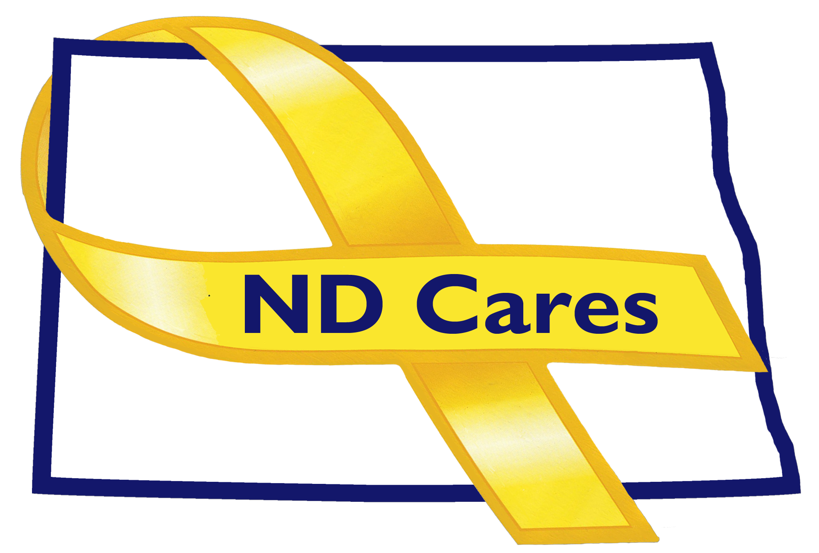
COALITION MEETING AGENDA
1:00 pm – 5:00 pm, January 16th, 2018
Room 386 A&B, RJ Bohn Armory, 4200 Mariam Avenue,
Bismarck, ND
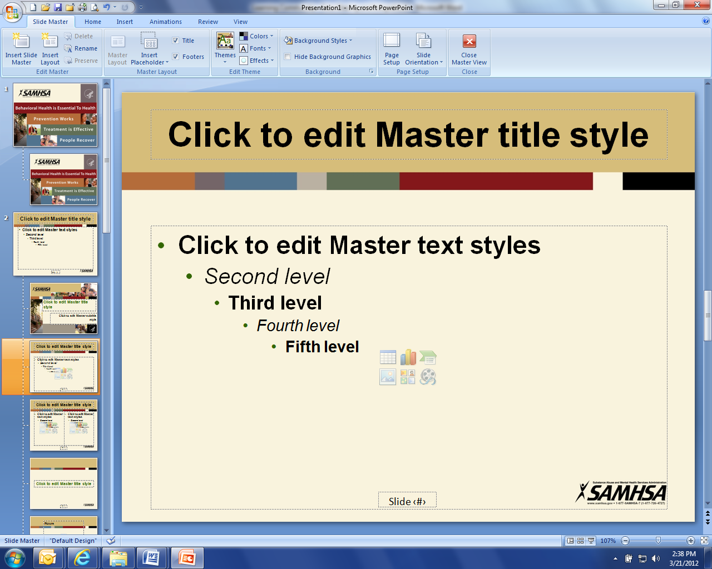

1:00 pm Welcome and Introductions (Connie Sprynczynatyk)
Administrative Updates:
- Website, Community Program, Upcoming Events, Newsletter/TeleConferences (Joe)
- Regional Training, Business Initiative, Budget, Timeline, Due outs (Darcie)
Guest Presentation(s):
- Lorraine Davis, Founder/Executive Director, Native American Development Center(NADC) -- Native American Development Center Overview

Member updates:
- Alison Traynor – Suicide Prevention State Plan
- Rebecca Quinn - Brain Injury Network Initiatives for March
- Pam Sagness – North Dakota’s Behavioral Health Reform
- Jason Sutheimer, HR Manager - Job Service ND Overview

3:00 pm Break

3:15 pm Strategic Plan review and assignments (Connie/Darcie)

5:00 pm Closing Remarks (Connie)

