COALITION MEETING AGENDA
1:00 pm – 4:30 pm, Jan 24th, 2019
RJB Armory Room #387, 4200 Miriam Ave, Bismarck, ND
The dial in number for the meeting is: 1-855-509-2650; passcode: 32015#
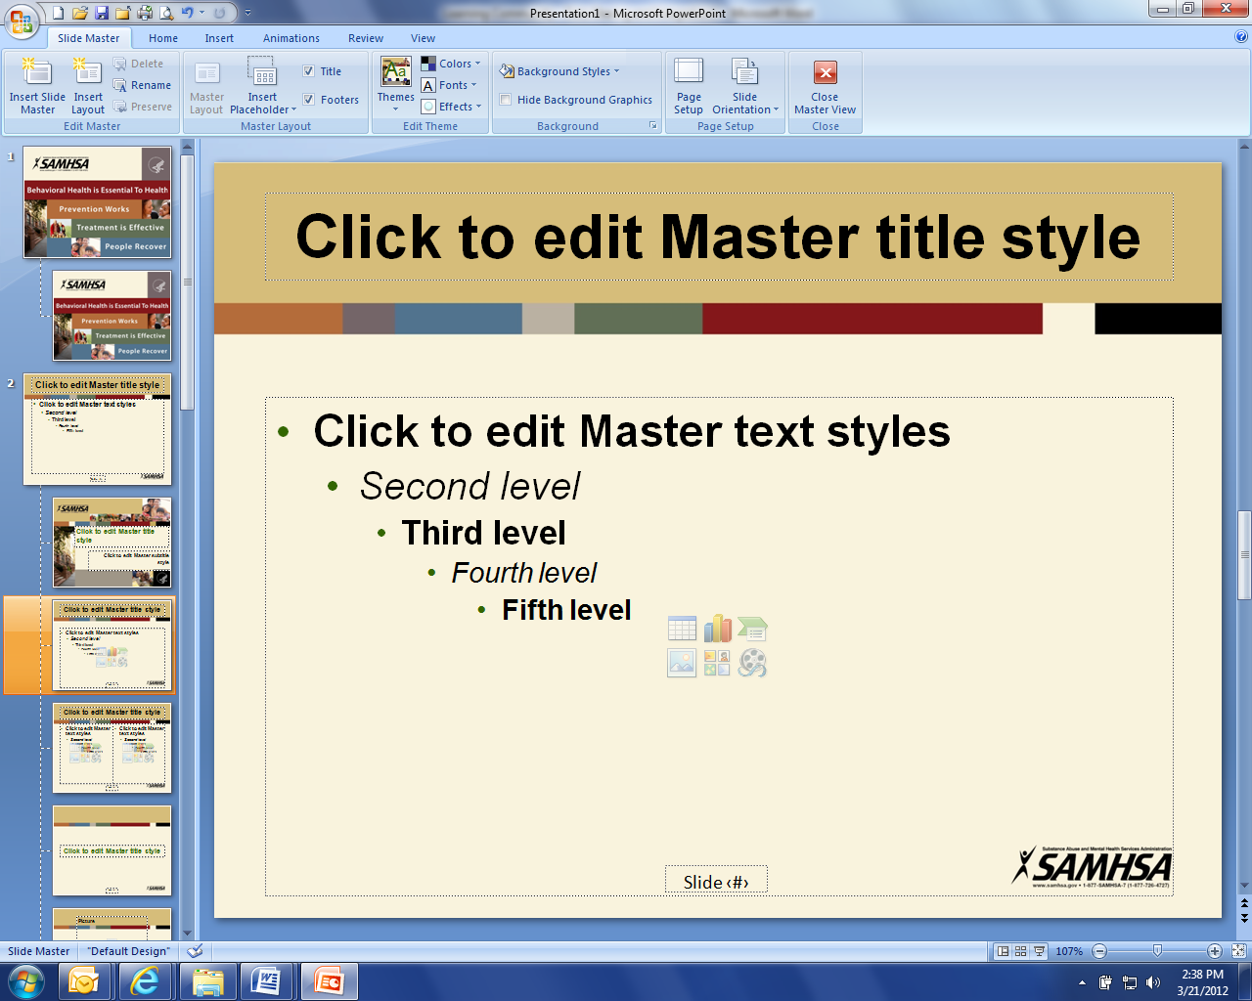
1:00 pm Welcome and Introductions (Connie)

1:10 pm FirstLink (Cindy Miller)
- Year in Review
- Texting initiative
- Addiction pilot program

1:30 pm Legislative Initiatives Updates (Connie will announce break)
- Rebecca Quinn – TBI Network
- Pam Mack – Protection and Advocacy
- Lisa Peterson – Department of Corrections and Rehabilitation
- Pam Sagness – Behavioral Health Division
- Lonnie Wangen – ND Department of Veterans Affairs
- Major General Dohrmann – ND National Guard

3:15 pm Break

3:30 pm Coalition member updates (All)

4:00 pm Administrative Updates: (Darcie/Joe)
- Community Program
- Website, Newsletter and Tele-conferences
- Business Initiative
- Regional training
- Budget

4:15 pm Strategic Plan Objectives update (Darcie)

4:25 pm Upcoming events: (Darcie)
- Executive Committee Meetings: Feb 27, Mar 20, Apr 24, May 22, Jun 19, Aug 21.
- Employment Mentorship Summit – January 30th, 2019 - Minot

4:30 pm Closing (Connie)

