COALITION MEETING AGENDA
10:00 am – 3:00 pm, May 9th, 2018
RJB Armory Room #387, 4200 Miriam Ave, Bismarck, ND
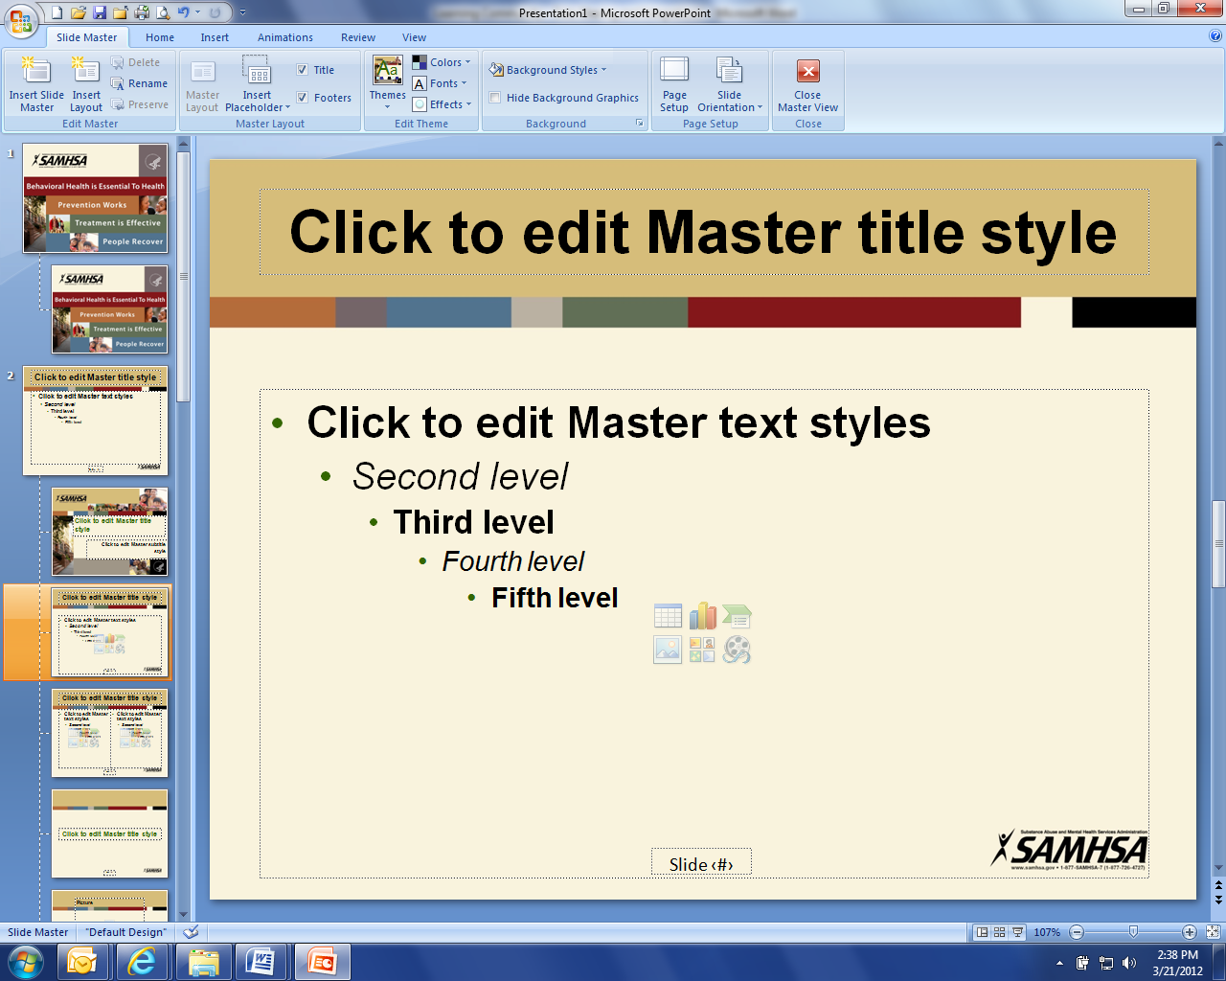
10:00 am Welcome and Introductions (Connie Sprynczynatyk)
Administrative Updates:
- Joe - Website, Community Program, Upcoming Events, Newsletter/Tele-conferences, Tri-fold update
- Darcie - Regional Training, Business Initiative, Budget (Charitable Donation Usage), Timeline, Due outs, Databook Update,
  - Issues from stakeholder
    - NDNG – HSC’s are out-of-network providers in Tricare
    - ND Cares Behavior Health Training

10:30 am Lisa Peterson – DOCR Incarceration Reform and legislative initiatives

11:00 am Pam Sagness – Overall Health – ND’s Behavioral Health Reform and legislative initiatives

11:30 am Lonnie Wangen – ND DVA program update and legislative initiatives

12:00 pm Major General Dohrmann – ND National Guard legislative initiatives

12:30 pm Lunch with Guest Presentation:
- Lorraine Davis, Founder/Executive Director, Native American Development Center(NADC) -- Native American Development Center Overview

1:30 pm Coalition Member discussions on successes, initiatives, legislative proposals, and support needs from ND Cares
- MN Veterans Court - https://www.hometownsource.com/sun_patriot/program-assists-veterans-in-courts/article_c429da98-0140-11e8-a4f1-c7fd4e4501cf.html

2:15 pm Strategic Plan Objective Updates (Connie/Darcie/Joe)

2:40 pm Upcoming meetings (EC: 12 Jun, Coalition: Aug 2018; Veterans Legislative Caucus: Nov/Dec 2018)

2:45 pm Closing

