ND Cares Executive Committee Meeting
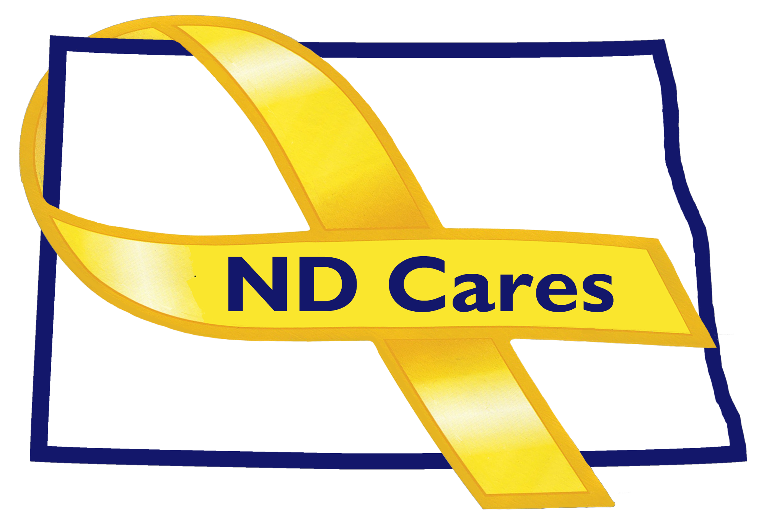
August 21, 2019

Attendees: Connie Sprynczynatyk, Dale Dekrey(Telephone), MG Alan Dohrmann, Cindy Whitesell (Telephone), Lonnie Wangen (Telephone), Pam Sagness (Telephone), Joyal Meyer (Telephone), Davina French, LTC Pat Flanagan Darcie Handt, Joe Faller

Absent: Robert Black

1. Minutes. Minutes from the June 19, 2019 accepted as written. However, Lonnie provided clarification to the last sentence in 2nd paragraph of EC Members update. The clarification is that while not all private institutions are involved in the academic credit for military service process, the University of Mary has been participating.

2. Due outs.
- No due outs to cover.

3. Old Business/Tasks Pending.
- Kalix was the last business to join; currently at 18. Should consider the CEO for the NG Commanders program. Very supportive of the military. Currently have BCBS of ND (Caring Foundation) and Excel Energy that will donate to the ND National Guard Foundation. MG Dohrmann said there is no reason to wait on those donations as the HB 1101 adjusted process will not affect how these monies are received as long as they are ok with the purposes of the Guard Foundation. Money will need to be requested, by the Office of the Adjutant General, from the ND National Guard Foundation, for funding to conduct an ND Cares event.
- Pembina was added as the newest community; currently 48.
- The strategic plan; goal #1 update – Continue to pull data from State License records and compare to the 211 database, reconcile, and provide feedback for accuracy. Next step is to pull data from the Secretary of State and compare to 211. Will be submitting an idea to create a state licensing entity to include local agencies. Goal #2; Darcie is working an MOU with the Universities about continued instruction of Military Culture and Suicide Prevention training within their course of study.

4. New Business:
- No changes to coalition membership. Full-time staffing has changed. Joe is now working 2 days a week; 20-25 hrs a week. Darcie’s final day is October 4th. A position description is being worked and an announcement will be published soon for the Executive Director position. Discussed the hiring board consist of 2 ND Cares Executive Team members and an external individual. MG Dohrmann mentioned more closely integrating ND Cares in the staff functions within the Office of the Adjutant General. There are items ND Cares works on that also comes up through TF MIND, ND Compass, ACOVA, and the Commissioners office.
- The new website is live. Provide feedback if you see improvements that can be made.
- The ND Suicide Prevention Coalition is in the process of establishing itself. Bylaws have been established, unincorporated entity registration done, and the ND Community Foundation relationship has been established so that they are prepared to receive money. Still working to build website and marketing. Also working an annual conference, possibly in January. Joyal is also a member of the committee. Sanford, Corporate Initiative Team, has the Zero Suicide implementation and are implementing parts of the program corporate wide. Sanford Bismarck has contracted with the 2-1-1 follow-up program. Unclear if the follow-up program, through 211, will continue for free. The grant that was used to establish the follow-up program was not renewed.

- EC Members updates:
  - Cindy had no updates.
  - Lonnie talked about the Commissioners Challenge; sent out a challenge to state agencies and looks to move to county and city entities. Good visit with VA leadership last week; other states are looking to implement. Discussed other state doing something similar including Alaska. Looking to get businesses to get the S.A.V.E. program as wellness credit. VA is going forward with their governor’s challenge. Legislative updates sent to Jay for next session.
  - Dale; the Fargo VA will be hosting the VA Community Mental Health Summit in Minot tomorrow, approx. 100-200 individuals in attendance. Appreciate the S.A.V.E. push by Lonnie. Davina asked about the Women’s Health Summit. Requested the dates be provided as soon as possible for the upcoming events in Minot, Bismarck, Fargo so we can get the word out.
  - Joyal talked about the upcoming Bismarck Out of the Darkness Walk. Asked if the ND Cares hosts a booth; no. Asked if we could look at doing one next year, co-sponsored by ND Cares/Dept of Health/Dept of Human Services. Connie talked about sharing information about 211 and others in the coalition at an event like this. Joyal feels we could help increase the media attention for this and other events. Davina talked about this as an opportunity to include our and Survivors piece. Darcie talked about maybe a live remote at an event like this.
  - Pam talked about all of the legislative intiatives passed in some shape or form. Currently implementing new programs to include Pier support. Certified Pier support will become a Medicaid billed program in July 2020. 1915i State Plan Amendment; will be able to add service to the Medicaid plan, mental illness, Substance Use Disorder and Brain Injury. Need to transition behavior health from a social service, charity, grant writing system into a true reimbursable health care system. We discussed the volunteer Pier system as well as the certified pier program. Pier support is currently reimbursable through the Free through Recovery and not through Medicaid. Legislature also funded Behavior Health Crisis Service in all regions. So there will be mobile crisis team in all regions.
  - LTC Flannagan; that the NDNG has sent out the Commissioners challenge to 2500 individual contact list. Released it on 3 different Facebook pages, placed on NDKO, and distributed to our suicide intervention officers. Sent to retirees. Changed FY20 training guidance to add S.A.V.E. training as mandatory. Moving forward with the Dept of Health, Dept of Public Instruction and Behavior Health on Suicide Prevention Training.
  - MG Dohrmann; talked about the upcoming NDNG September Standdown. Opportunity for leaders to check in at the lowest level. Talked about the NG has not had a suicide in the last 2 years but ideations are up, and we have lost retirees to suicide.
  - Laura talked about how they are moving forward with the legislative issues that passed. The Behavior Health Conference is in November at the Bismarck Event Center. Through the legislative process they were given an FTE to manage the Pier Support.
- Robert Black; did not attend.
- Connie; discussed some of the past of ND Cares and looking to the future. Thanked Darcie for his efforts, and then talked about the strength of our coalition partners.

5. Upcoming events:

- VA Mental Health Summit, Minot, August 22^{nd.}
- Brats for the Brave, Bismarck, September 11th.
- Coalition meeting September 12th.
- Vital Services conference, Jamestown, September 17-19
- Multi County Veterans Wellness Conference, Belcourt, September 18-19.
- Community Clergy Training, West Fargo VFW, September 19th
- North Central Stand down, Minot, October 24th

Respectfully submitted,

Darcie Handt, Executive Director

