ND Cares Executive Committee Meeting
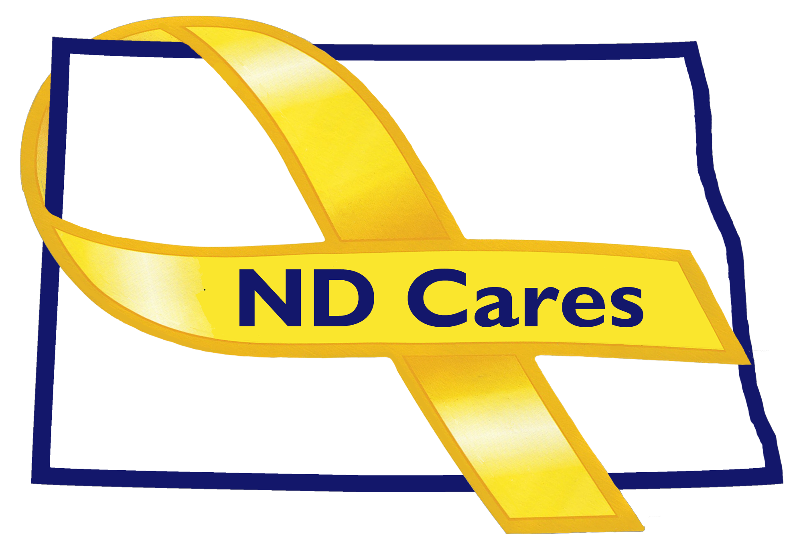
June 19, 2019

Attendees: Connie Sprynczynatyk, Dale Dekrey(Telephone), MG Alan Dohrmann, Robert Black (Telephone), Cindy Whitesell (Telephone), Bryan Watters (Telephone), Laura Anderson, Darcie Handt, Joe Faller

Absent: Pam Sagness, Joyal Meyer, Lonnie Wangen

1. Minutes. Minutes from the April 24, 2019 accepted as written.

2. Due outs.
- The Fargo ND Cares Training was conducted on May 22nd. The training was set up by the Fargo/West Fargo steering committees. About 40 people attended and the event was held at the West Fargo VFW. The event was sponsored by Sysco. Surveys following the event were very positive.

3. Old Business/Tasks Pending.
- Kalix newest business; currently 18. Will be conducting a certificate presentation on Jun 25th. An invite to the Minot and Minot Air Force base steering committees will be sent.
- No new communities since last meeting; currently 47. Went to Argusville to present certificate, good conversation about their community. Darcie talked about re-tooling the way we work with communities. The Military Outreach will begin engaging with the communities to help foster their programs.
- The strategic plan; goal #1 update – In July, Darcie will work with Firstlink to compare resources in their database and those listed with the Secretary of State. New Firstlink television and radio ads will begin in July. Also in July a new ad for the ND Veterans home will begin. Goal #2; Darcie will follow up with Minot State University about continued instruction of Military Culture and possibly Suicide training within their course of study. Darcie also talked about the metric briefing he has been working on for MG Dohrmann.

4. New Business:
- A proposed new member to the coalition is David Becker. David is the new ambassador for the Army Reserve. No objections.
- The new website will go live on June 25th.
- Darcie discussed his meeting with Alison Traynor, Nicole Veselka and members of the Sanford implementation team. Sanford realized they need a bigger group to discuss implementing Zero Suicide. Next meeting is July 9th.

- EC Members updates:
  - Cindy talked about the Minot ND Cares event scheduled for June 27th at a local Minot park.
  - Bryan talked about the SAVE training challenge. Working with Darcie and Psycharmor to track those that complete the SAVE training. Darcie is working with Fortis and Sysco for sponsorship. Also updated us on the tracking of college academic credit for military service. The plan has been approved by the ND University System for the 100 & 200 level courses. Now working on the 300 and 400 level courses. Also working on the communication plan to get the information to those looking at attending a ND University. Connie asked about the private institutions; currently the private institutions are not involved in this process.
  - Dale; Discussed that the VA requires SAVE training for employees so there should be 1,000 people involved in the training. Also asked that if there are outreach events that his folks could attend/help, let them know.
  - MG Dohrmann; talked about co-sponsoring the SAVE training. Talked about formally integrating ND Cares into the National Guard staff; more discussion will take place to determine the correct location. Arnie Strebe is now the president of the National Guard Foundation and currently looking at others to be a part of the group.
  - Laura talked about how they are moving forward with the legislative issues that passed. The Behavior Health Conference is in November at the Bismarck Event Center. Through the legislative process they were given an FTE to manage the Pier Support.
- Robert Black; nothing to add.
- Connie; talked about the changes to the Secretary of the Army; more moves to follow. Mentioned that a letter will go out to David Becker welcoming him to the coalition.

5. Upcoming events:

- Executive Committee Meeting, August 21st.
- VA Mental Health Summit, Minot, August 22nd
- Coalition meeting September 12th.

Respectfully submitted,

Darcie Handt, Executive Director

