ND Cares Executive Team
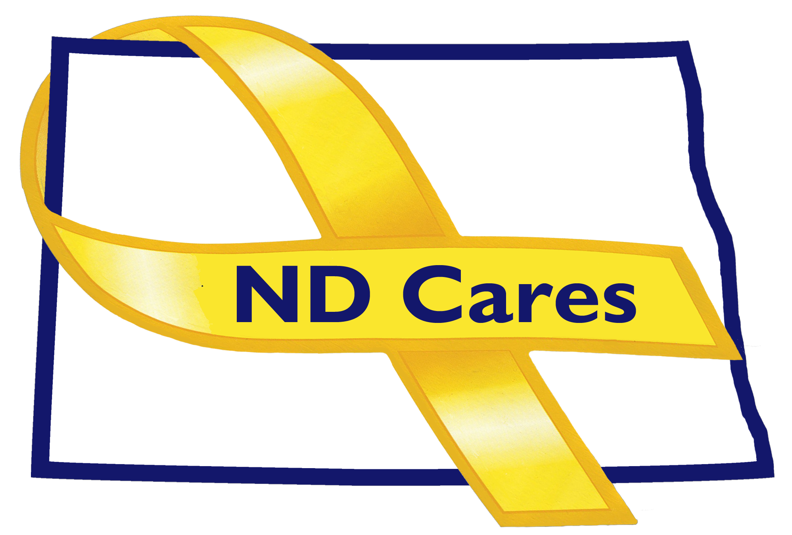
AGENDA
10:30 a.m. – 12:00 p.m.
December 20th, 2019
Fraine Barracks – Bldg 030 - Bismarck, ND
Chair – Connie Sprynczynatyk Co-Chair – Cindy Whitesell

Legislative Team: Connie Sprynczynatyk; Davina French; Lonnie Wangen

The dial in number for the meeting is: 1-701-333-2840; Call ID: 32015#, PIN: 32015#

- OPENING.
  - Comments (Connie)
  - We Honor Veterans – “Hospice” presentation.
  - Approve Executive Committee Meeting minutes from October 23rd, 2019.

- REVIEW OF DUE-OUTS. (Darcie).
  - Community Reconnect Concept
  - Community Clergy Training Program in Western ND, January 30th, Medora ND.

- OLD BUSINESS.
  - ND Cares Business Update (Darcie)
i. (18) No Update
  - ND Cares Community Update (Darcie)
    - (48) No Update
  - Strategic Plan Update (Darcie)
    - Goal 1 progress
    - Goal 2 progress

- NEW BUSINESS.
  - Coalition Membership (Darcie)
    - New members of the Executive Committee were sent an email to complete application.
  - Social Media – No Update (Joe)
  - ND Suicide Prevention Coalition (Darcie)
  - Approve Strategic Planning goal & objectives (Connie)
  - Executive Committee Member Updates
    - EC Co-Chair
    - ND DVA (Commissioners Challenge)
    - Regional VA
    - ND Dept of Health
    - ND Dept of Human Services, Behavioral Health Division
    - ND National Guard
    - Mr. Black
    - Ms. Sprynczynatyk

- UPCOMING EVENTS.
  - ND Suicide Prevention Coalition Annual Conference, January 22nd, 2020. Bismarck, ND
  - Community Clergy Training, January 30th, 2020. Medora, ND.

- NEXT MEETING DATE(s).
  - TBD

