ND Cares Executive Team
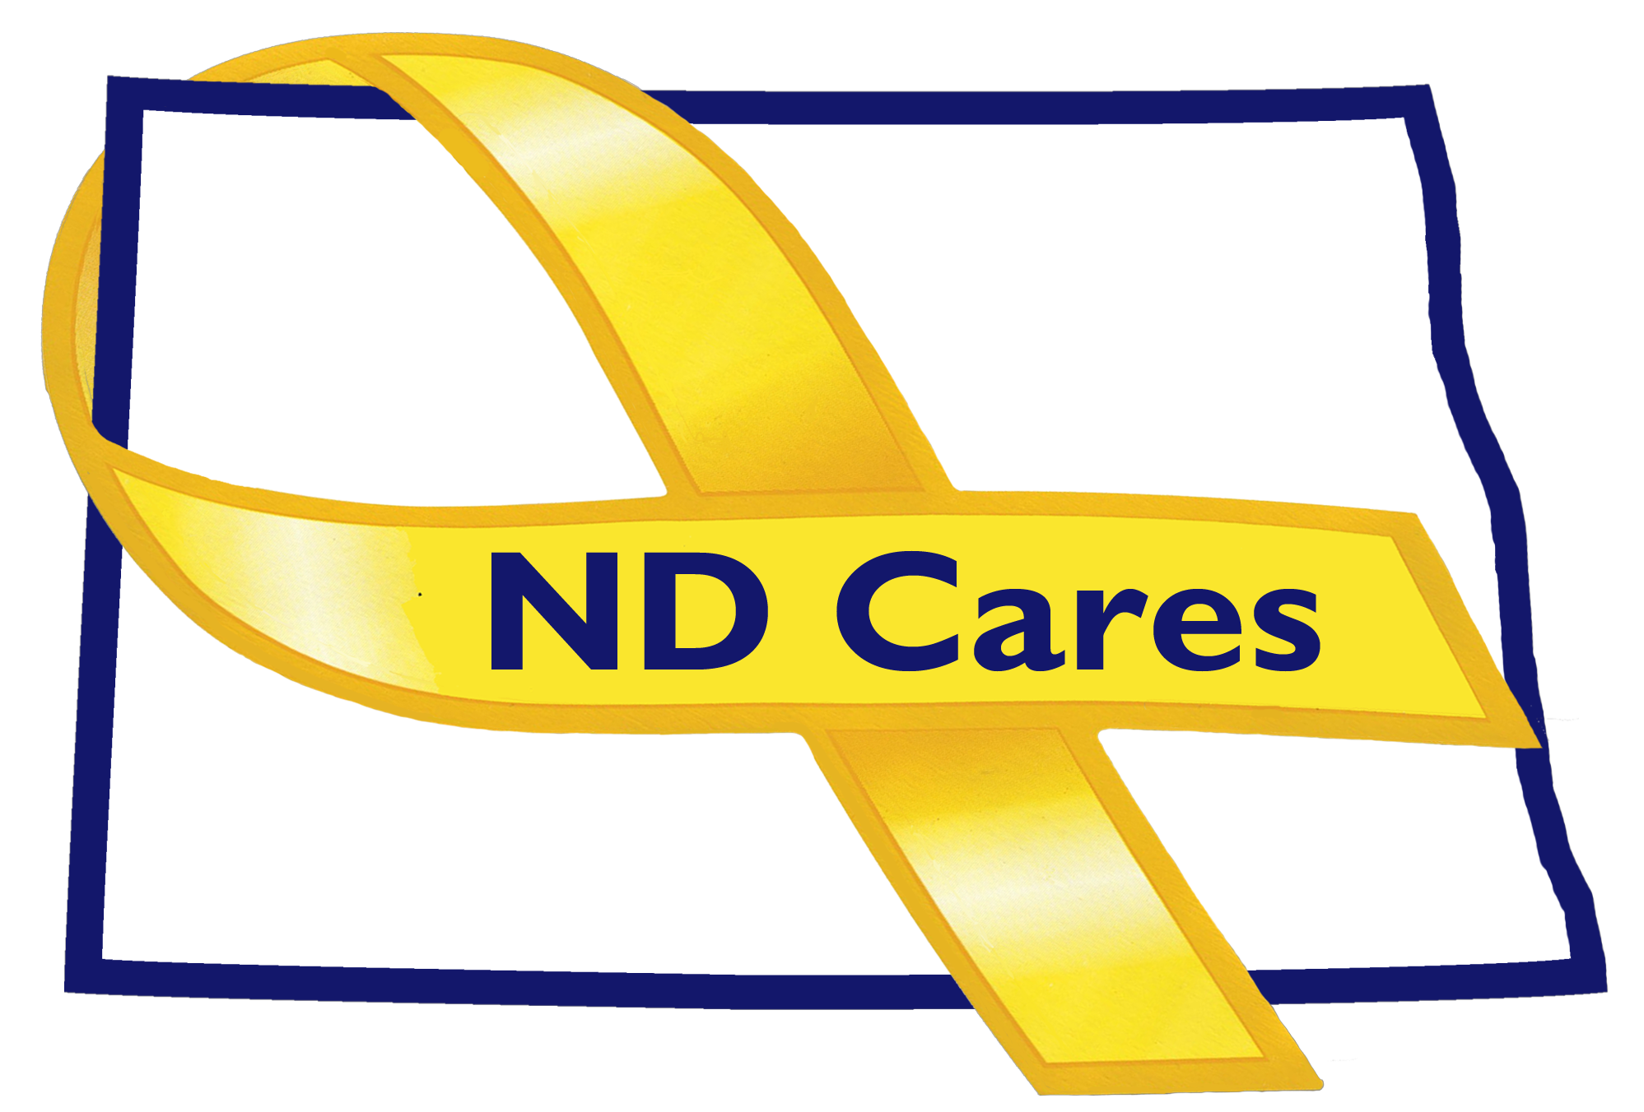
AGENDA
10:00 a.m. – 11:30 a.m.
October 23rd, 2019
Fraine Barracks – Bldg 030 - Bismarck, ND
Chair – Connie Sprynczynatyk Co-Chair – Cindy Whitesell

Legislative Team: Connie Sprynczynatyk; Davina French; Lonnie Wangen

The dial in number for the meeting is: 1-701-333-2840; Call ID: 32015#, PIN: 32015#

- OPENING.
  - Comments (Connie)
  - Approve Executive Committee Meeting minutes from August 21st, 2019.

- REVIEW OF DUE-OUTS. (Darcie).
  - PsychArmor Institute Partnership
  - Community Reconnect Concept
  - Community Clergy Training Program in Western ND

- OLD BUSINESS.
  - ND Cares Business Update (Darcie)
i. (18)
  - ND Cares Community Update (Darcie)
    - Pembina (48)
  - Strategic Plan Update (Darcie/Connie) (NSTR)
    - Goal 1 progress
    - Goal 2 progress

- NEW BUSINESS.
  - Coalition Membership (Darcie)
    - BG Huber, DAG NDNG
    - Reserve Ambassador
    - Other recommendations
  - Social Media – NSTR (Joe)
  - ND Suicide Prevention Coalition (Darcie)
  - Strategic Planning workshop discussion (Connie)
  - Executive Committee Member Updates
    - EC Co-Chair
    - ND DVA (Commissioners Challenge)
    - Regional VA
    - ND Dept of Health
    - ND Dept of Human Services, Behavioral Health Division
    - ND National Guard
    - Mr. Black
    - Ms. Sprynczynatyk

- UPCOMING EVENTS.
  - North Central Veterans Stand Down, Minot, October 24th, 2019
  - Recovery Reinvented, November 12th, 2019
  - Behavioral Health Conference, November 13th – 15th, 2019
  - ND Suicide Prevention Coalition Annual Conference, January 22nd, 2020

- NEXT MEETING DATE(s).
  - November 21st, 2019 (Thursday)

