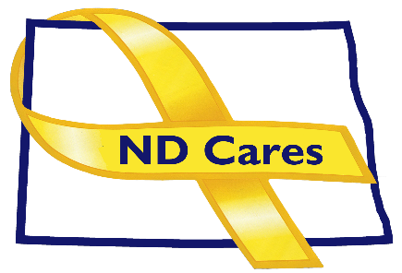
ND Cares Executive Team
AGENDA
1:30 a.m. – 3:00 p.m.
August 18, 2021
Fraine Barracks – Bldg. 30 - Bismarck, ND
Virtual Meeting Call – In: 701-328-0950 Conference ID: 857 126 446#
Click here to join the meeting via Microsoft Teams on computer or mobile app
Chair – Connie Sprynczynatyk Co-Chair – Cindy Whitesell

- OPENING
  - Comments (Connie)
  - Approve Executive Committee Meeting minutes from July 14, 2021.
- OLD BUSINESS
  - ND Cares Business Update (ED)
    - Current number of businesses: 19
  - ND Cares Community Update (ED)
    - Current number of communities: 49
  - Donations
  - TRICARE
  - Strategic Plan Update: Objective 1.3 Develop and implement a strategic communication plan that addresses stigma. American Legion Department Commander Partnership.

- NEW BUSINESS
- United North Dakota – referral and contact management system
- Executive Committee Member Updates
    - Co-Chairperson
    - ND DVA
    - Regional VA
    - ND Dept. of Health
    - ND Dept. of Human Services, Behavioral Health Division
    - ND National Guard
    - Army Reserve Ambassador for North Dakota
    - Chairperson

- UPCOMING EVENTS
- ND Brain Injury Network Concussion Symposium: Sept. 17th
- 911 Memorial (20 yrs.): Sept. 11, 10am, GWOT Memorial, Fraine Barracks
- Behavioral Health Peer Support In-Person Training: Sept. 13-17, Fargo
- Behavioral Health Peer Support In-Person Training: Sept. 13-17, Fargo
- ACOVA Meeting – Sept., 23-24, Bismarck
- North Central Veterans Stand Down – Oct. 21, Minot
- ND Behavioral Health & Children and Family Services Conference: Oct. 26-28

- NEXT MEETING DATES
a. ND Cares Coalition Meeting, Sept. 16, 2021
b. ND Cares Executive Committee Meeting, Oct. 6, 2021.

