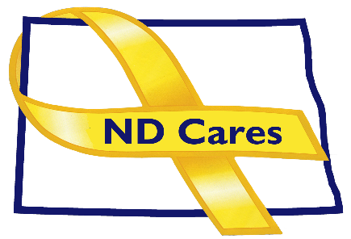
ND Cares Executive Team
AGENDA
10:30 a.m. – 12:00 p.m.
February 4, 2021
Fraine Barracks – Bldg 30 - Bismarck, ND
Virtual Meeting Call – In: 701-328-0950 Conference ID: 988 013 282#
Click here to join the meeting via Microsoft Teams
Chair – Connie Sprynczynatyk Co-Chair – Cindy Whitesell

- OPENING
  - Comments (Connie)
  - Approve Executive Committee Meeting minutes from January 7, 2021.

- OLD BUSINESS
  - ND Cares Business Update (ED)
    - Current number of businesses: 19
      - Minot State University
  - ND Cares Community Update (ED)
    - Current number of communities: 48
    - Community Reconnect Update: 15
      - Minot
      - Washburn

- NEW BUSINESS
- Strategic Plan Update: Objective 1.2 Strengthen peer-to-peer support.
  - Peer Mentor Support: Survivor and Mental Health/Substance Use
- ND Military Data Book Distribution
- Legislation tracking
- Executive Committee Member Updates
    - Co-Chairperson
    - ND DVA
    - Regional VA
    - ND Dept. of Health
    - ND Dept. of Human Services, Behavioral Health Division
    - ND National Guard
    - Army Reserve Ambassador for North Dakota
    - Chairperson

- UPCOMING EVENTS
  - VA Vaccination Event –RJB Armory in Bismarck - Feb 11, and Mar 11, 2021
  - VA Vaccination Event – Minot Armed Forces Reserve Center - Mar 3, 2021
  - ND Suicide Prevention Coalition Conference - Facebook Live - February 24, 2021 8:30- 3:00

- NEXT MEETING DATES
a. ND Cares Coalition Meeting, March 3, 2021?
b. ND Cares Executive Committee Meeting, April 1, 2021.

