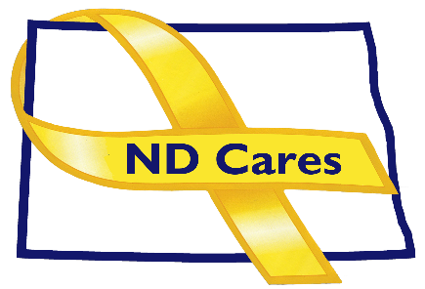
ND Cares Executive Team
AGENDA
10:30 a.m. – 12:00 p.m.
April 1, 2021
Fraine Barracks – Bldg 30 - Bismarck, ND
Virtual Meeting Call – In: 701-328-0950 Conference ID: 831 694 055#
Click here to join the meeting via Microsoft Teams
Chair – Connie Sprynczynatyk Co-Chair – Cindy Whitesell

- OPENING
  - Comments (Connie)
  - Approve Executive Committee Meeting minutes from February 4, 2021.

- OLD BUSINESS
  - ND Cares Business Update (ED)
    - Current number of businesses: 19
  - ND Cares Community Update (ED)
    - Current number of communities: 48
    - Community Reconnect Update: 14
      - Grand Forks

- NEW BUSINESS
- Strategic Plan Update: Objective 1.1 Build Awareness of Resources/1.3Develop and implement a strategic plan that address stigma
    - Gap: Assess healthcare provider training to determine if the training is working to reduce sigma and offer assistance if needed.
- Veterans Care Coordination Coalition update
- Executive Committee Member Updates
    - Co-Chairperson
    - ND DVA
    - Regional VA
    - ND Dept. of Health
    - ND Dept. of Human Services, Behavioral Health Division
    - ND National Guard
    - Army Reserve Ambassador for North Dakota
    - Chairperson

- UPCOMING EVENTS
a. VA Vaccinations
- Devils Lake, Camp Grafton - 2nd dose April 1
- Jamestown, Gladstone Inn & Suites - 2nd dose April 7
- Bismarck, RJB Armory - 2nd dose - April 8
- Grand Forks, NDNG Armory - 2nd dose - April 21
- Dickinson NDNG Armory - 2nd dose - Apr 14, Time: 1000-1300
- Williston - UMDHU Hanger - 2nd dose - Apr 13, Time: 1000-1300, 408 Airport Rd
- Minot - Armed Forces Reserve Center - 2nd dose - April 28
b. Behavioral Health Peer Support Training
    - Virtual – April 26-30
    - In Person – June 28-July 2, Grand Forks, Minot, Bismarck, Fargo
  - Memorial Day Ceremony May 31 Heritage Museum/Veterans Cemetery Mandan
- NEXT MEETING DATES
a. ND Cares Coalition Meeting, June 2, 2021
b. ND Cares Executive Committee Meeting, May 6, 2021.

