ND Cares Executive Team
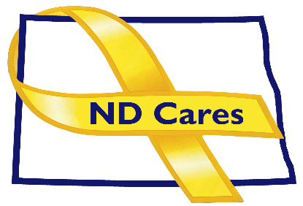
AGENDA
1:30 a.m. – 3:00 p.m.
November 17, 2021
Fraine Barracks – Bldg. 30 - Bismarck, ND

Virtual Meeting Call – In: 701-328-0950 Conference ID: 241 827 29 #
Click here to join the meeting via Microsoft Teams on computer or mobile app
Chair – Connie Sprynczynatyk Co-Chair – Cindy Whitesell

- OPENING
  - Comments (Connie)
  - Approve Executive Committee Meeting minutes from October 6, 2021.

- PRESENTATION: TBD
- OLD BUSINESS
  - ND Cares Business Update (ED)
    - Current number of businesses: 19
  - ND Cares Community Update (ED)
    - Current number of communities: 50
  - Strategic Plan Update

- NEW BUSINESS
- Executive Committee Member Updates
    - Co-Chairperson
    - ND DVA
    - Regional VA
    - ND Dept. of Health
    - ND Dept. of Human Services, Behavioral Health Division
    - ND National Guard
    - Army Reserve Ambassador for North Dakota
    - Chairperson

- UPCOMING EVENTS
- Homeless Veterans Stand Down: Nov 17, Fargo VA
- VA COVID Vaccination Event: Nov 17, RJB Armory, Bismarck
- ACOVA Meeting: Nov. 18-19
- First Link Suicide Risk Assessment: Live One Hour Webinar: Nov 18, Fargo
- First Link Adult Mental Health First Aid: Nov 30, Fargo.
- Behavioral Health Dealing with Grief and Loss: Dec 21
- Behavioral Health Peer Support Training: For those who secured employment contingent upon peer support training. Jan 10
- Minot Military Affairs Committee: Dec 2, Minot
- TAPS Peer Mentor Virtual Training: Dec 8
- Wreaths Across America: Dec 18, ND Veterans Cemetery, Mandan
- Fargo/Moorhead Military Affairs Committee: Dec 23, Fargo
- VA Flu Shot Events in Nov/Dec: See the VA website for locations.

- NEXT MEETING DATES
a. ND Cares Coalition Meeting, Dec. 9, 2021
b. ND Cares Executive Committee Meeting (proposed) Jan.12, 2021.

