ND Cares Executive Team
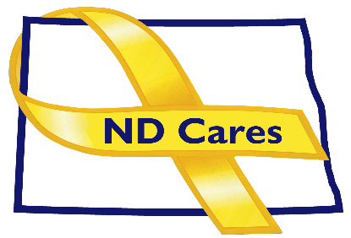
AGENDA
10:30 a.m. – Noon
March 9, 2021
Fraine Barracks – Bldg. 30 - Bismarck, ND

Virtual Meeting Call – In: 701-328-0950 Conference ID: 313 302 197#
Click here to join the meeting via Microsoft Teams on computer or mobile app
Chair – Shelly Sizer Co-Chair – Cindy Whitesell

- OPENING
  - Comments (Shelly)
  - Approve Executive Committee Meeting minutes from January 12, 2022.

- PRESENTATION: Tragedy Assistance Program for Survivors (TAPS) Memorandum of Understanding for Survivor Outreach activities with the National Guard Bureau (Davina French)
- OLD BUSINESS
  - ND Cares Business Update (ED)
    - Current number of businesses: 19
  - ND Cares Community Update (ED)
    - Current number of communities: 51
  - Strategic Plan Update
  - Governor’s Challenge
  - TRICARE

- NEW BUSINESS
- Executive Committee Member Updates
    - Co-Chairperson
    - ND DVA
    - Regional VA
    - ND Dept. of Health
    - ND Dept. of Human Services, Behavioral Health Division
    - ND National Guard
    - Army Reserve Ambassador for North Dakota
    - Chairperson

- UPCOMING EVENTS
- Counseling on Access to Lethal Means Virtual Training: March 10
- First Link Adult Mental Health Fist Aid: Devils Lake/ Bottineau: March 16/17
- ACOVA Meeting: May 19, 20, Veterans Club, Steele
- Brain Injury Network Mind Matters Virtual Conference: March 24-25
- TAPS Peer Mentor Virtual Training: Mar 28 and Apr 25
- National Disabled Veterans Summer Sports Clinic: Registration opens April 1
- VA Powerful Tools for Caregivers online series: April 7 – May 12
- First Link Suicide Risk Assessment Webinar: April 21
- First Link Suicide Prevention Awareness Film Festival: April 28, Fargo Theater
- NEXT MEETING DATES
- ND Cares Coalition Meeting, May 5, 2021
- ND Cares Executive Committee Meeting (proposed) April 7, 2021.

