ND Cares Executive Team
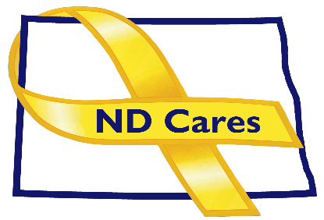
AGENDA
10:30 a.m. – Noon
Dec 8, 2022
Fraine Barracks – Bldg. 30 - Bismarck, ND

Virtual Meeting Call – In: 701-328-0950 Conference ID: 373 940 722#
Click here to join the meeting via Microsoft Teams on computer or mobile app
Chair – Shelly Sizer Co-Chair – Cindy Whitesell

- OPENING
  - Comments (Shelly or Cindy)
  - Approve Executive Committee meeting minutes from July 7, 2022.
- Presentation: TBA
- NEW BUSINESS
- Executive Committee Member Updates
    - Co-Chairperson
    - ND DVA
    - Regional VA, Fargo
    - ND Dept. of Health
    - ND Dept. of Human Services, Behavioral Health Division
    - ND National Guard
    - Army Reserve Ambassador for North Dakota
    - Chairperson

- OLD BUSINESS
  - ND Cares Business Update
    - Current number of businesses: 22
  - ND Cares Community Update
    - Current number of communities: 55
  - Bridges for the Fallen Update
  - Strategic Plan Update
  - Governor’s Challenge
  - TRICARE
- UPCOMING EVENTS
- ND 2023 Legislative Calendar of Deadlines
- Grand Forks Military Affairs Committee: Dec 21
- Fargo/Moorhead Military Affairs Committee: 11 a.m. Feb 9
- Devils Lake Military Affairs Committee: Dec 18
- AFSP Talk Saves Lives Virtual Event: Dec. 12, 7:00 pm
- Wreaths Across America Ceremony: Dec 17, 11 am, Vets Cemetery, Mandan
- Wreaths Across America Ceremony: Dec 17, 11 am, National Vets Cemetery, Fargo
- VA PACT Act Town Hall: Dec 12, 9-10 am, Fargo VA Medical Center
- Minot Military Affairs Committee: Jan 5
- Williston Military Affairs Committee: Jan 6
- TAPS Alaska Iditarod Survivor Experience Applications Due: Dec 30
- First Link ASIST Training: January 24-25 9:00 am 5:00 pm, Fargo $240
- ACOVA Meeting: Feb 16-17 Comfort Inn, Bismarck

- NEXT MEETING DATES
- ND Cares Coalition Meeting, Feb 9th, 2023 1:00 pm-4:00 pm
- ND Cares Executive Committee Meeting (proposed) Jan 5 or 12, 2023, 10:30 am-Noon

