ND Cares Executive Team
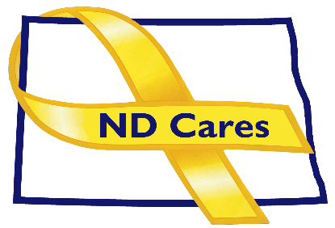
AGENDA
10:30 a.m. – Noon
February April 6, 2023
Fraine Barracks – Bldg. 30 - Bismarck, ND

Virtual Meeting Call – In: 701-328-0950 Conference ID: 781 804 48#
Click here to join the meeting via Microsoft Teams on computer or mobile app
Chair – Shelly Sizer Co-Chair – Cindy Whitesell

- OPENING
  - Comments (Shelly or Cindy)
  - Approve Executive Committee meeting minutes from February 9, 2023.
- NEW BUSINESS
- Executive Committee Member Updates
    - Co-Chairperson
    - ND DVA
    - Regional VA, Fargo
    - ND Dept. of Health
    - ND Dept. of Human Services, Behavioral Health Division
    - ND National Guard
    - Army Reserve Ambassador for North Dakota
    - Chairperson

- OLD BUSINESS
  - ND Cares Business Update
    - Current number of businesses: 22
  - ND Cares Community Update
    - Current number of communities: 58
  - Legislative Update
  - Hidden Wound Bridge Dedication
  - Data Book
  - Governor’s Challenge
- UPCOMING EVENTS
- ND 2023 Legislative Calendar of Deadlines
- Month of the Military Child Where Red Day: Apr.7
- North Dakota Suicide Prevention Coalition Annual Meeting: April 11, 1:30-3:30
- Disabled Veterans Deer Hunt in Nov, Camp Grafton: Applications due Apr. 29
- FirstLink Various Trainings: March-June
- DAV State Convention: May 5-7, Baymont Mandan
- ND Reserve Officers Assoc. Conv.: May 6, Hilton Garden Inn, Fargo
- Governor’s Challenge Innovation Conf: May 9-11, Washington DC
- ACOVA: May 11-12, Camp Grafton
- AMVETS State Conv.: May-12-13, AMVETS Club, Steel
- Veterans Treatment Court Opening Ceremony: May 15
- VA Veterans Baby Shower: May 22, American Red Cross, Fargo
- Memorial Day/Columbarium Dedication: May 29, Veterans Cemetery, Mandan
- Memorial Day: May 29, 3:00 PM, National Cemetery Fargo
- Tribal Veterans Stand Down: June 7-8, Spirit Lake
- VFW State Conv.: June 8-11, Bismarck
- Governor’s Challenge Implementation Acad.: Jun 13-15, Washington DC
- Summit on Behavioral Health in Energy Country: Jun 21-22, Dickinson
- American Legion State Conv.: June 22-25, Bismarck

- NEXT MEETING DATES
- Coalition Mtgs 2023: March 2, June 1, Sept 7, Dec 7, from 1:00-4:00 pm.
- Executive Committee Mtgs 2023: April 6, May 4, July 6, Aug 3, Oct 5, and Nov 2, from 10:30-Noon.

