ND Cares Executive Team
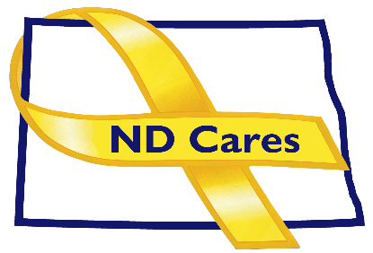
AGENDA
10:30 a.m. – Noon
October 5, 2023
Virtual

Virtual Meeting Call – In: 701-328-0950 Conference ID: 398 367 801 #
Click here to join the meeting via Microsoft Teams on computer or mobile app.
Chair – Shelly Sizer Co-Chair – Cindy Whitesell

- OPENING
  - Comments (Shelly or Cindy)
  - Approve Executive Committee meeting minutes from August 3, 2023.

- PRESENTATION: TBD
- NEW BUSINESS
- Executive Committee Member Updates
    - Co-Chairperson
    - ND DVA
    - Regional VA, Fargo
    - ND Dept. of Health
    - ND Dept. of Human Services, Behavioral Health Division
    - ND National Guard
    - Army Reserve Ambassador for North Dakota
    - Chairperson

- OLD BUSINESS
  - ND Cares Business Update
    - Current number of businesses: 24
      - Mandan Automotive Group
  - ND Cares Community Update
    - Current number of communities: 58
  - Governor’s Challenge Update
  - Hidden Wounds Bridge
  - Other
- UPCOMING EVENTS
- Service Dogs of America: Fall Volunteer Day, Oct 7, Jud
- AFSP Out of the Darkness Walks:: Oct 8, Valley City
- Behavioral Health & Children Services Conference (in-person/virtual): Oct 24-26, Bismarck
- Buddy Check Week, Oct 16-20
- Film: I Married the War, Oct 17, Bijou Theater, Beach ND & Oct 19 Fargo Air Museum
- Minot Stand Down: Oct. 19, Armed Forces Reserve Center, Minot
- Governor’s Challenge Team Mtg: Nov 8, Virtual
- ACOVA: Nov16-17, American Legion Post 29, Watford City
- FirstLink: Suicide Risk Assessment: Live One Hour Webinar, Dec 5
- AFSP Out of the Darkness Walks:: Oct 8, Valley City

- NEXT MEETING DATES
- Coalition Mtgs 2023: Dec 7, from 1:00-4:00 pm.
- Executive Committee Mtgs 2023: Nov 2, from 10:30-Noon.

