ND Cares Executive Team
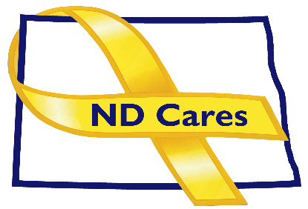
AGENDA
10:30 a.m. – Noon
July 6, 2023
Fraine Barracks – Bldg. 30 - Bismarck, ND

Virtual Meeting Call – In: 701-328-0950 Conference ID: 389 184 093#
Click here to join the meeting via Microsoft Teams on computer or mobile app
Chair – Shelly Sizer Co-Chair – Cindy Whitesell

- OPENING
  - Comments (Shelly or Cindy)
  - Approve Executive Committee meeting minutes from May 4, 2023.

- PRESENTATION:
- NEW BUSINESS
- Executive Committee Member Updates
    - Co-Chairperson
    - ND DVA
    - Regional VA, Fargo
    - ND Dept. of Health
    - ND Dept. of Human Services, Behavioral Health Division
    - ND National Guard
    - Army Reserve Ambassador for North Dakota
    - Chairperson

- OLD BUSINESS
  - ND Cares Business Update
    - Current number of businesses: 23
      - Dakota Care Home, Aug 9 TBD
  - ND Cares Community Update
    - Current number of communities: 58
  - Governor’s Challenge Update
  - Star Behavioral Health Program
- UPCOMING EVENTS
- FirstLink Various Trainings: Mental Health First Aid, July 11, Dickinson
- VVA Annual Meeting: Jul 14-16, Willow Park Mayville, 10:00am
- Military Day at the Fair: July 25, Minot
- Military Appreciation Day at the Zoo: July 26, Minot
- VA Caregivers Conference: Aug 2
- ND Women’s Leadership Summit: Aug 3, Avalon Center, Fargo.
- Vets in the Park (Veterans Appreciation Event): Aug 2, University Park, Grand Forks
- Bismarck Stand Down: Aug. 24, AMVETS Club
- ND Suicide Prevention Coalition Conference (in-person/virtual): Sept 14, Bismarck State College
- Governor’s Challenge Post Implementation Site Visit.: Aug. 22-23, Bismarck & Fargo
- ACOVA: Sept. 14-15, Veterans Club, Steele
- AFSP Out of the Darkness Walks: Sept – Oct, Various Locations
- ND County & Tribal VSO Training: Oct 2-5, Baymont Inn, Mandan
- Behavioral Health & Children Services Conference (in-person/virtual): Oct 24-26, Bismarck

- NEXT MEETING DATES
- Coalition Mtgs 2023: Sept 7, Dec 7, from 1:00-4:00 pm.
- Executive Committee Mtgs 2023: Aug 3, Oct 5, and Nov 2, from 10:30-Noon.

