ND Cares Executive Team
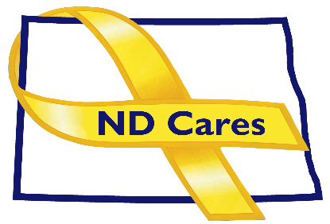
AGENDA
10:30 a.m. – Noon
November 2, 2023
Virtual

Virtual Meeting Call – In: 701-328-0950 Conference ID: 486 154 74 #
Click here to join the meeting via Microsoft Teams on computer or mobile app.
Chair – Shelly Sizer Co-Chair – Cindy Whitesell

- OPENING
  - Comments (Shelly or Cindy)
  - Approve Executive Committee meeting minutes from October 5, 2023.

- PRESENTATION: TBD
- NEW BUSINESS
- Executive Committee Member Updates
    - Co-Chairperson
    - ND DVA
    - Regional VA, Fargo
    - ND Dept. of Health
    - ND Dept. of Human Services, Behavioral Health Division
    - ND National Guard
    - Army Reserve Ambassador for North Dakota
    - Chairperson

- OLD BUSINESS
  - ND Cares Business Update
    - Current number of businesses: 24
  - ND Cares Community Update
    - Current number of communities: 58
  - Governor’s Challenge Update
  - Hidden Wounds Bridge
  - Other
- UPCOMING EVENTS
- Military Family Appreciation Month: November
- ND State Historical Society Veterans Program: Nov 7, 9am-11am, Heritage Ctr. Bismarck
- Star Behavioral Health Provider Training: Tier One Training Nov 8
- Fargo Vet Center Open House: Nov 8. 11 am-2pm
- Veterans Day: Nov. 11
- ND Veterans Cemetery Columbarium Cutting: 3:00 PM, Nov. 11, Mandan
- Native American Veterans Virtual Symposium: 1-3 PM, Nov. 15
- Governor’s Challenge Team Mtg: Nov 8, Virtual
- ACOVA: Nov 16-17, American Legion Post 29, Watford City
- International Survivors of Suicide Loss Day: Nov. 18
- FirstLink Trainings: Nov-Dec
- Wreaths Across America: Dec.16, Mandan, Fargo

- NEXT MEETING DATES
- Coalition Mtgs 2023: Dec 7 and 2024: Mar 7, Jun 6, Sept. 5, Dec 5, from 1:00-4:00 pm.
- Executive Committee Mtgs 2024: Jan 4, Feb 1, Apr 4, May 2, July 11, Aug 1, Oct 3, Nov 7 from 10:30-Noon.

