ND Cares Executive Team
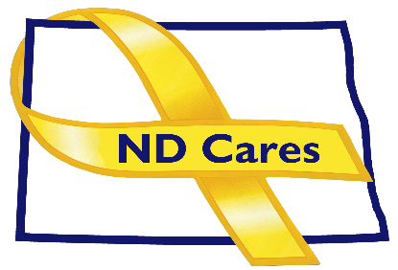
AGENDA
10:30 a.m. – Noon
January 12, 2022
Fraine Barracks – Bldg. 30 - Bismarck, ND

Virtual Meeting Call – In: 701-328-0950 Conference ID: 404 083 915#
Click here to join the meeting via Microsoft Teams on computer or mobile app
Chair – Shelly Sizer Co-Chair – Cindy Whitesell

- OPENING
  - Comments (Shelly or Cindy)
  - Approve Executive Committee meeting minutes from Dec 8, 2022.
- Presentation: TBA
- NEW BUSINESS
- Executive Committee Member Updates
    - Co-Chairperson
    - ND DVA
    - Regional VA, Fargo
    - ND Dept. of Health
    - ND Dept. of Human Services, Behavioral Health Division
    - ND National Guard
    - Army Reserve Ambassador for North Dakota
    - Chairperson

- OLD BUSINESS
  - ND Cares Business Update
    - Current number of businesses: 22
  - ND Cares Community Update
    - Current number of communities: 55
  - Bridges for the Fallen Update
  - Strategic Plan Update
  - Governor’s Challenge
- UPCOMING EVENTS
  - ND 2023 Legislative Calendar of Deadlines
  - First Link ASIST Training: January 24-25 9:00 am 5:00 pm, Fargo $240
  - Meet FirstLink Virtual Presentation: Jan 31
  - Grand Forks Military Affairs Committee: Jan 18
  - Fargo/Moorhead Military Affairs Committee: Feb 9
  - Devils Lake Military Affairs Committee: Jan 26
  - Minot Military Affairs Committee: Feb 2
  - Williston Military Affairs Committee: Feb 3
  - VA S.A.V.E Virtual Training: Jan 19, and Feb 16. Contact Tammy Monsebroten for information.
  - Behavioral Health Webinar, Question, Persuade, Refer: February 21, 2023
  - VA CALM Virtual Training: Mar 15 Contact Sarah Kemp-Tabbut for information.
  - NDHHS Ethics of Peer Support: Mar 15, 2023
  - ND Brain Injury Network 2023 Mind Matters Conference: Mar 23-24, 2023, Mandan
  - ACOVA Meeting: Feb 16-17 Comfort Inn, Bismarck

- NEXT MEETING DATES
- ND Cares Coalition Meeting, March 2, 2023 1:00 pm-4:00 pm
- ND Cares Executive Committee Meeting (proposed) Feb 9, 2023, 10:30 am-Noon

