ND Cares Executive Team
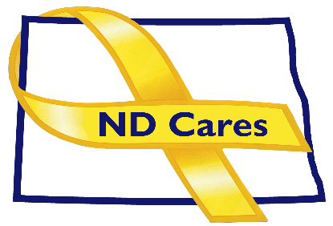
AGENDA
10:30 a.m. – Noon
April 4, 2024
Virtual

Virtual Meeting Call – In: 701-328-0950 Conference ID: 318 723 540 #
Click here to join the meeting via Microsoft Teams on computer or mobile app.
Chair – Shelly Sizer Co-Chair – Cindy Whitesell

- OPENING
  - Comments (Shelly or Cindy)
  - Approve Executive Committee meeting minutes from Feb 1, 2024.
- PRESENTATION: TBD
- NEW BUSINESS
- Executive Committee Member Updates
    - Co-Chairperson
    - ND DVA
    - Regional VA, Fargo
    - ND Dept. of Health
    - ND Dept. of Human Services, Behavioral Health Division
    - ND National Guard
    - Army Reserve Ambassador for North Dakota
    - Chairperson
- OLD BUSINESS
  - ND Cares Business Update
    - Current number of businesses: 24
      - University of Jamestown
  - ND Cares Community Update
    - Current number of communities: 58
  - Strategic Plan Update
  - Governor’s Challenge Update
  - Hidden Wounds Bridge
  - Other
- UPCOMING EVENTS
- STAR Behavioral Health Providers: March-April Training
- FirstLink: April- June Trainings
- VA COMPACT Act Stand Down: April 30, AMVETS, Bismarck
- Western ND Honor Flight: April 14-15
- Month of the Military Child: April.
- NDNG ASIST Training: Free, May 8-9, NW Human Service Center, Williston. Email: alzeller@nd.gov to register.
- Military Women’s Conference: May 11, Minot Municipal Auditorium, Minot. Register buy May 1. Contact Jim Davenport 701-822-3242
- Hidden Wounds Bridge Dedication: May 16, 2:00 Buffalo Mall, Jamestown
- ACOVA: May 16-17, Fairfield Inn, Jamestown
- AMVET State Convention: May 17-19, Ramada by Wyndham, Fargo
- Behavioral Health Conference: Sept 16-19, Bismarck Event Center (Virtual, In-Person)
- Fargo VA Community Mental Health Summitt: Aug. 14, Fargo Armed Forces Reserve Center
- TWV Suicide Prevention Symposium: Sept. 30, Minot

NEXT MEETING DATES
- Coalition Mtgs 2024: Jun 6, Sept. 5, Dec 5, from 1:00-4:00 pm.
- Executive Committee Mtgs 2024: May 2, July 11, Aug 1, Oct 3, Nov 7 from 10:30-Noon.

