ND Cares Executive Team
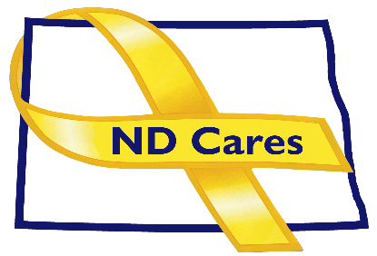
AGENDA
10:30 a.m. – Noon
February 1, 2024
Virtual

Virtual Meeting Call – In: 701-328-0950 Conference ID: 320 849 5 #
Click here to join the meeting via Microsoft Teams on computer or mobile app.
Chair – Shelly Sizer Co-Chair – Cindy Whitesell

- OPENING
  - Comments (Shelly or Cindy)
  - Approve Executive Committee meeting minutes from January 4, 2023.

- PRESENTATION: Sanford Health Veterans Ambassador Program, Paul Weckman, US Navy (Ret), Head of Military and Veteran Affairs
- NEW BUSINESS
- Executive Committee Member Updates
    - Co-Chairperson
    - ND DVA
    - Regional VA, Fargo
    - ND Dept. of Health
    - ND Dept. of Human Services, Behavioral Health Division
    - ND National Guard
    - Army Reserve Ambassador for North Dakota
    - Chairperson

- OLD BUSINESS
  - ND Cares Business Update
    - Current number of businesses: 24
  - ND Cares Community Update
    - Current number of communities: 58
  - Governor’s Challenge Update
  - Hidden Wounds Bridge
  - TRICARE
  - Other
- UPCOMING EVENTS
- STAR Behavioral Health Providers: January Training
- VA Virtual S.A.V.E. Training: Feb 20, Mar 19th 9AM-10:30AM, email Tammy to register tammy.monsebroten@va.gov.
- VFW State Mid-Winter Conference: Feb 16-18, VFW Post 7564, West Fargo
- ACOVA: Feb 8-9, Expressway Suites, Fargo
- FirstLink: Feb-Mar Trainings
- Western ND Honor Flight: April (TBD)
- VA Fargo Creative Arts Competition Classification Handbook due Mar.
- ND League of Cities Spring Workshop: Mar 19-20, Clarion Hotel, Minot
- Governors Challenge Mortality Review Academy: Mar 19-21, Pheonix AZ
- ND Brain Injury Network: 2024 Mind Matters Conference, Mar 21-21, Fargo.
- Vietnam Veterans Welcome Home Celebration: Mar. 29, Armed Forces Reserve Center, Minot.

- NEXT MEETING DATES
- Coalition Mtgs 2024: Mar 7, Jun 6, Sept. 5, Dec 5, from 1:00-4:00 pm.
- Executive Committee Mtgs 2024: Apr 4, May 2, July 11, Aug 1, Oct 3, Nov 7 from 10:30-Noon.

