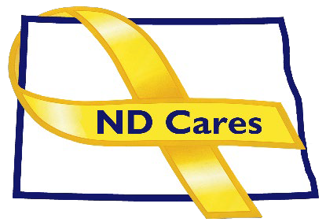
ND Cares Executive Team
AGENDA
10:30 a.m. – Noon
April 2, 2026
Virtual

Click here to join the meeting via Microsoft Teams on computer or mobile app.
Call-In: 701-328-0950 Conference ID: 337 754 534#
Chair – Todd Remington
- OPENING
  - Comments (Todd)
  - Approve the Executive Committee meeting minutes from January 8, 2026.
- NEW BUSINESS
  - Executive Committee Member Updates
    - Chair/Co-Chairperson
    - ND DVA
    - Regional VA, Fargo
    - ND Dept. of Health & Human Services, Health Division
    - ND Dept. of Health & Human & Services, Behavioral Health Division
    - ND National Guard
    - Army Reserve Ambassador for North Dakota
- OLD BUSINES
  - ND Cares Business Update: 30
  - ND Cares Community Update: 61
  - Strategic Plan Update (NDBA)
  - Governor’s Challenge Update
  - ADA Compliance

- UPCOMING EVENTS
- FirstLink Trainings
- Star Behavioral Health Providers Training
- ND Brain Injury Network Events
- Vets for Vets Minot Events
- Military Couples Relationship Retreat: Minot April 17-19 & Grand Forks June 12-14
- Celebrate America: April 18-19, AMVETS, Bismarck
- Fergus Falls VA Clinic Grand Opening: April 29
- Grand Forks Clinic Grand Opening: April 30
- AFSP Soul Shop Fargo (Faith Leader Training): May 5, Fargo, May 7, Minot
- VA Veteran Baby Shower: May 5, American Red Cross, Fargo
- ACOVA: May 7-8, Minot
- CALM Clinical Workshop: Virtual June 2, Register here
- CALM Conversations Workshop: Virtual June 9, Register here
- Safety Planning Workshop: Virtual June 15, Register here
- Vet Fest: June 17, Fargo
- NEXT MEETING DATES

Coalition Mtgs 2026: Jun. 4, Sept. 3, Dec. 3 from 1:00-3:00 pm
Executive Committee Mtg 2026: May 7, Jul. 2, Aug. 6, Oct. 1, Nov. 5 from 10:30-Noon.

