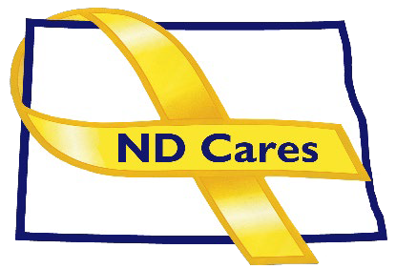
ND Cares Executive Team
AGENDA
10:30 a.m. – Noon
January 8, 2026
Virtual

Click here to join the meeting via Microsoft Teams on computer or mobile app.
Call-In: 701-328-0950 Conference ID: 625 376 912#
Co-Chair – Cindy Whitesell
- OPENING
  - Comments (Cindy)
  - Approve the Executive Committee meeting minutes from December 4, 2025.
- NEW BUSINESS
  - Executive Committee Member Updates
    - Co-Chairperson
    - ND DVA
    - Regional VA, Fargo
    - ND Dept. of Health & Human Services, Health Division
    - ND Dept. of Health & Human & Services, Behavioral Health Division
    - ND National Guard
    - Army Reserve Ambassador for North Dakota
  - Statement of Interests filing requirements
- OLD BUSINES
  - Chairman Discussion
  - ND Cares Business Update: 29 – Prairie Recovery (Postponed)
  - ND Cares Community Update: 60 – Cities of Medina Jan 5. & Bowman - TBD
  - Strategic Plan Update (NDBA)
  - Governor’s Challenge Update

- UPCOMING EVENTS
- FirstLink Trainings
- Star Behavioral Health Providers Training
- ND Brain Injury Network Events
- CALM Conversations: Register
- Clinical CALM: Register
- Safety Planning Workshop: Register
- ND State Mortality Review Action Committee: Jan. 12
- ND Governors Challenge Virtual Team Meeting: Jan. 14
- ND Suicide Prevention Coalition Mtg: Jan 14
- VA Planning for the Future (Asst Living & Nursing Hm Options): Jan. 21, Register: contact Vickie Ness 701-239-3700 Extension 3561 vickie.ness@va.gov.
- Coroner’s Training: Supporting Military Families in a Death Investigation: Jan 22, Register
- ACOVA: Feb 5-7, GFAFB
- Fisher House Freeze Out Fundraiser: Feb. 6-7, West Acres Mall Fargo, Sign up
- NEXT MEETING DATES

Coalition Mtgs 2026: Mar.5, Jun. 4, Sept. 3, Dec. 3 from 1:00-3:00 pm
Executive Committee Mtg 2026: Apr. 2, May 7, Jul. 2, Aug. 6, Oct. 1, Nov. 5 from 10:30-Noon.

