ND Cares Executive Team
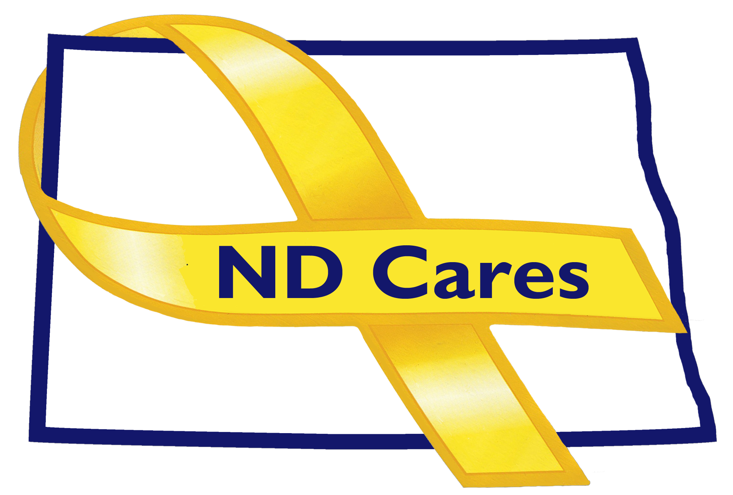
AGENDA
10:00 a.m. – 11:30 a.m.
Apr 24th, 2019
Fraine Barracks – Bldg 030 - Bismarck, ND
Chair – Connie Sprynczynatyk Co-Chair – Cindy Whitesell

Legislative Team: Co-Chairs – Connie Sprynczynatyk; Davina French; Lonnie Wangen

The dial in number for the meeting is: 1-855-509-2650; passcode: 32015#

- OPENING.
  - Comments (Connie)
  - Approve Executive Committee Meeting minutes from February 27th, 2019.

- REVIEW OF DUE-OUTS. (Darcie).
  - Community Conference Call update (Mar 7th)
  - Met with Dave Klein, Great Plains Housing Authority

- OLD BUSINESS.
  - ND Cares Business Update (Darcie)
i. Gate City Bank (17)
  - ND Cares Community Update (Joe)
    - Argusville (47)
  - Strategic Plan Update (Darcie/Connie)
    - Goal 1 progress
    - Goal 2 progress
    - Metrics

- NEW BUSINESS.
  - Coalition Membership (Darcie). NSTR.
  - Website Migration (Joe)
    - Timeline
    - Update (View)
  - Zero Suicide – Sanford (Darcie)
  - Fargo ND Cares Training (May 22, 2019) (Darcie)
  - Advertising (Vets Home, FirstLink, Minot)
  - Executive Committee Member Updates
    - EC Co-Chair
    - ND DVA
    - Regional VA
    - ND Dept of Health
    - ND Dept of Human Services, Behavioral Health Division
    - ND National Guard
    - Mr. Black
    - Ms. Sprynczynatyk

- UPCOMING EVENTS.
  - Peer Support Training, Bismarck, May 6-10, 2019
  - ND Cares Community Training for Region 5, Fargo, May 22nd, 2019
  - VA Mental Health Summit, Minot, August 22nd, 2019

- NEXT MEETING DATE(s).
  - Coalition Meeting, Bismarck, May 9th @ 1pm

