ND Cares Executive Team
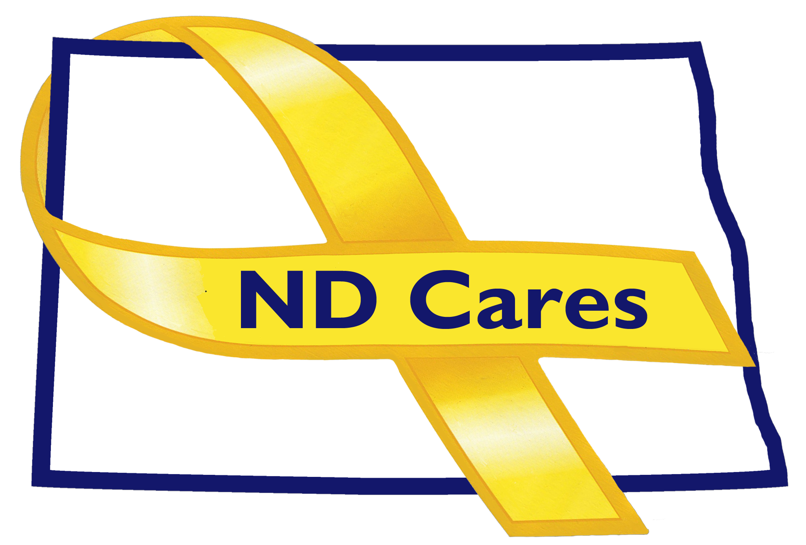
AGENDA
9:30 a.m. – 11:00 a.m.
April 4th, 2018
Fraine Barracks – Bldg 030 - Bismarck, ND
Chair – Connie Sprynczynatyk

Legislative Team: Co-Chairs – Connie Sprynczynatyk; Davina French; Lonnie Wangen

The dial in number for the meeting is: 1-855-509-2650; passcode: 32015#

- OPENING
  - Comments (Connie)
  - Approve Executive Committee Meeting minutes from Jan 3rd & Feb 28th, 2018

- REVIEW OF DUE-OUTS (Darcie). Nothing to report

- OLD BUSINESS / TASKS PENDING:
  - Website update (Joe)
  - ND Cares Community Program (Joe)
  - Marketing/Advertising Campaign (Darcie)
  - ND Cares Business Update (Darcie)
  - Newsletter & Community Conference Call April 19 (Darcie)
  - Strategic Plan Update (Darcie/Connie)
    - Goal 1 progress
    - Goal 2 progress

- NEW BUSINESS:
  - Coalition Membership:
    - Wayde Sick will be leaving the coalition due to a job move.
  - Executive Committee Member Updates (if needed)
    - ND DVA
    - Regional VA
    - Dept of Health, Suicide Prevention
    - ND Dept of Human Services, Behavioral Health Division
    - Minot AFB
    - ND National Guard
    - Mr. Black
    - Ms. Sprynczynatyk
    - Darcie Handt; 501(c)(3)

- Upcoming Events:
  - ND Cares Coalition Meeting – May 9th, 2018

- BIN (Darcie)
  - Add ND Housing Authority to Coalition (Darcie to work)
  - Add NDNG State family Support Volunteer (Ms. Hertz)

NEXT MEETING DATE(s):
- Coalition Meeting – May 9th, 2018

