ND Cares Executive Team
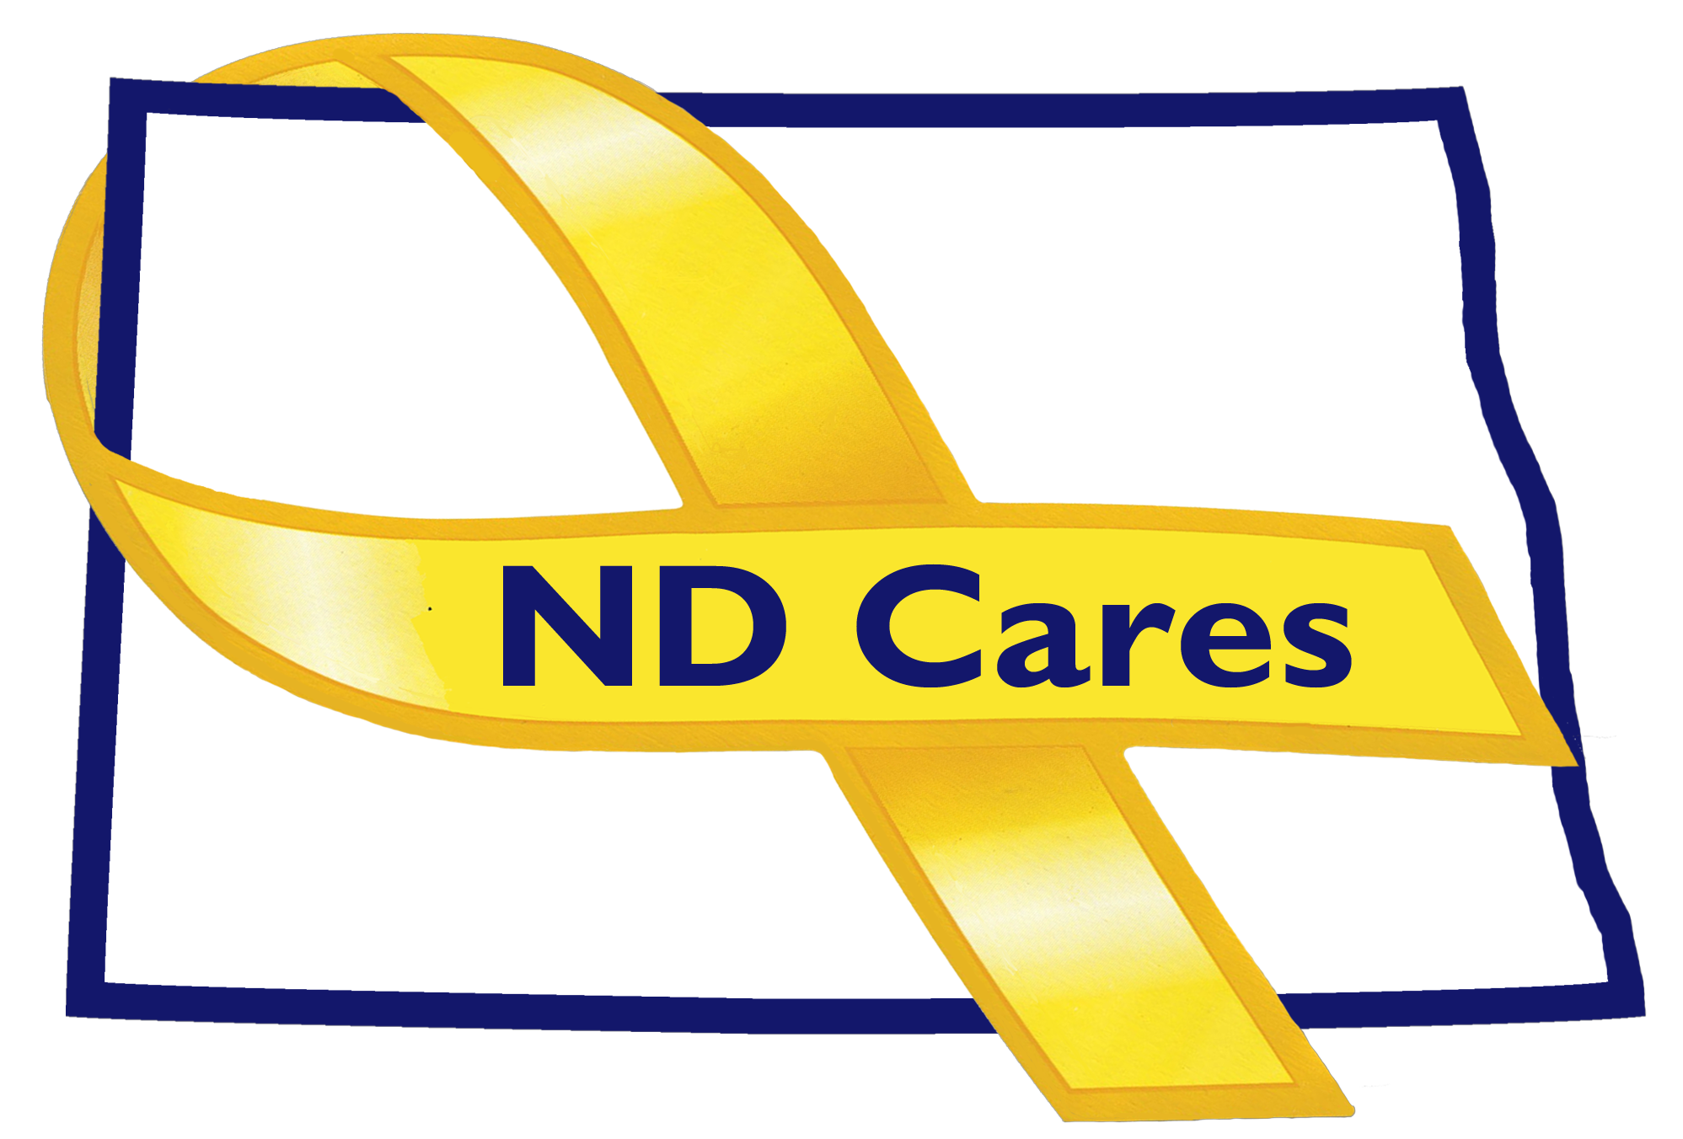
AGENDA
9:30 a.m. – 11:00 a.m.
Dec 4th, 2018
Fraine Barracks – Bldg 030 - Bismarck, ND
Chair – Connie Sprynczynatyk; Co-Chair – Cindy Whitsell

Legislative Team: Co-Chairs – Connie Sprynczynatyk; Davina French; Lonnie Wangen

The dial in number for the meeting is: 1-855-509-2650; passcode: 32015#

- OPENING.
  - Comments (Connie)
  - Approve Executive Committee Meeting minutes from September 13th, 2018.

- REVIEW OF DUE-OUTS. (Darcie).
  - Contact Soldier for Life – Done by Joe.
  - Dept of Commerce or Governors policy advisor as coalition member - Done by Darcie.
  - Darcie will compile the data for the Databook and get information to DHS for design – Done by Darcie

- OLD BUSINESS.
  - Website/Facebook update – NSTR (Nothing Significant to Report) (Darcie)
  - ND Cares Community Program (Darcie)
- Grand Forks Support Network
  - Marketing/Advertising Campaign - NSTR (Darcie)
  - ND Cares Business Update (Darcie)
- BCBS, Starion Bank, Fortis Energy, Coca Cola High Country - Minot
  - Review of Community Conference Call Oct 18th – NSTR (Darcie)
  - Strategic Plan Update (Darcie/Connie)
    - Goal 1 progress
    - Goal 2 progress
  - Bonnie Malo is the new representative for the Dept of Commerce vice Shawn Kessel.

- NEW BUSINESS.
  - Coalition Membership:
    - EC approves changes
  - Executive Committee Member Updates (if needed)
    - EC Co-Chair
    - ND DVA
    - Regional VA
    - Dept of Health, Suicide Prevention
    - ND Dept of Human Services, Behavioral Health Division
    - Minot AFB
    - ND National Guard
    - Mr. Black
    - Ms. Sprynczynatyk

- Upcoming Events.
  - ND Cares Legislative Day Jan 25th, 2019

- BIN. (Darcie)

NEXT MEETING DATE(s).
- Coalition Meeting – January 24th, 2019?

