ND Cares Executive Team
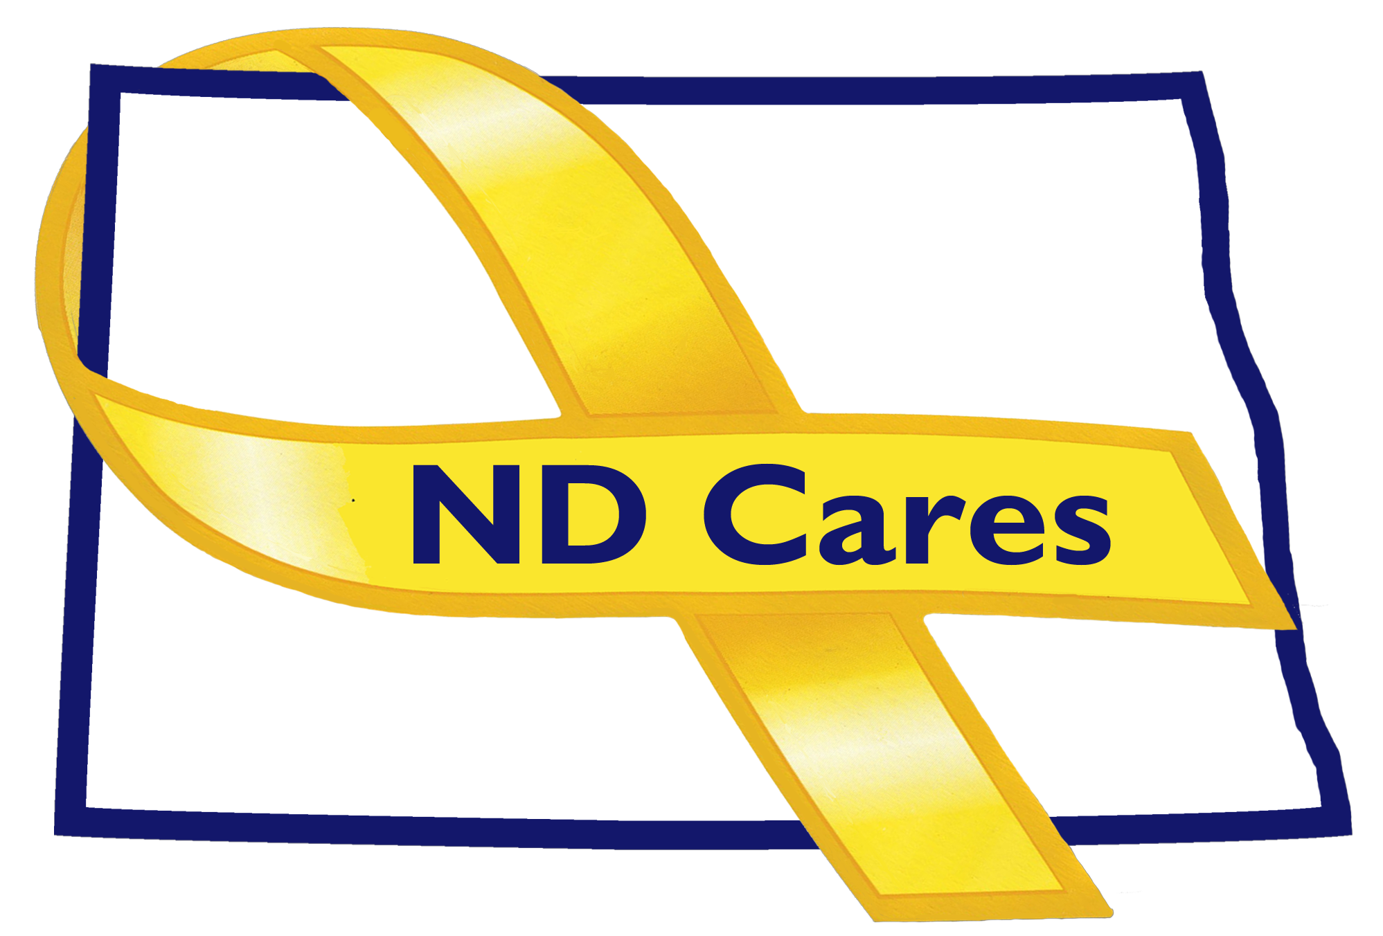
AGENDA
9:30 a.m. – 11:00 a.m.
January 3rd, 2018
Fraine Barracks – Bldg 030 - Bismarck, ND
Chair – Connie Sprynczynatyk
Co-Chair – Vacant

Legislative Team: Co-Chairs – Connie Sprynczynatyk; Davina French; Lonnie Wangen

The dial in number for the meeting is: 1-855-509-2650; passcode: 32015#

- OPENING
  - Comments (Connie)
  - Approve Executive Committee Meeting minutes from November 14th, 2017

- REVIEW OF DUE-OUTS (Darcie). Nothing to report

- OLD BUSINESS / TASKS PENDING:
  - Website update (Joe)
  - ND Cares Community Program (Joe)
  - Marketing/Advertising Campaign (Darcie)
  - ND Cares Business Update (Darcie)
  - Newsletter (Darcie)
  - Strategic Plan Update (Darcie/Connie)
    - Review Objectives
    - Assign Objective Owners

- NEW BUSINESS:
  - Executive Committee Member Updates (if needed)
    - ND DVA
    - Regional VA
    - Dept of Health, Suicide Prevention
    - ND Dept of Human Services, Behavioral Health Division update
    - Minot AFB
    - ND National Guard
    - Mr. Black
    - Ms. Sprynczynatyk

- Upcoming Events:
  - ND Cares Coalition Meeting – January 16th, 2018
  - Suicide Prevention Coalition Meeting – January 17th, 2018

- BIN (Darcie)
  - Executive Committee Co-Chair ?
  - Add ND Housing Authority to Coalition?
  - Add NDNG State family Support Volunteer (Ms. Hertz)?

NEXT MEETING DATE(s):
- Executive Committee Meeting - February ??, 2018

