ND Cares Executive Committee Meeting
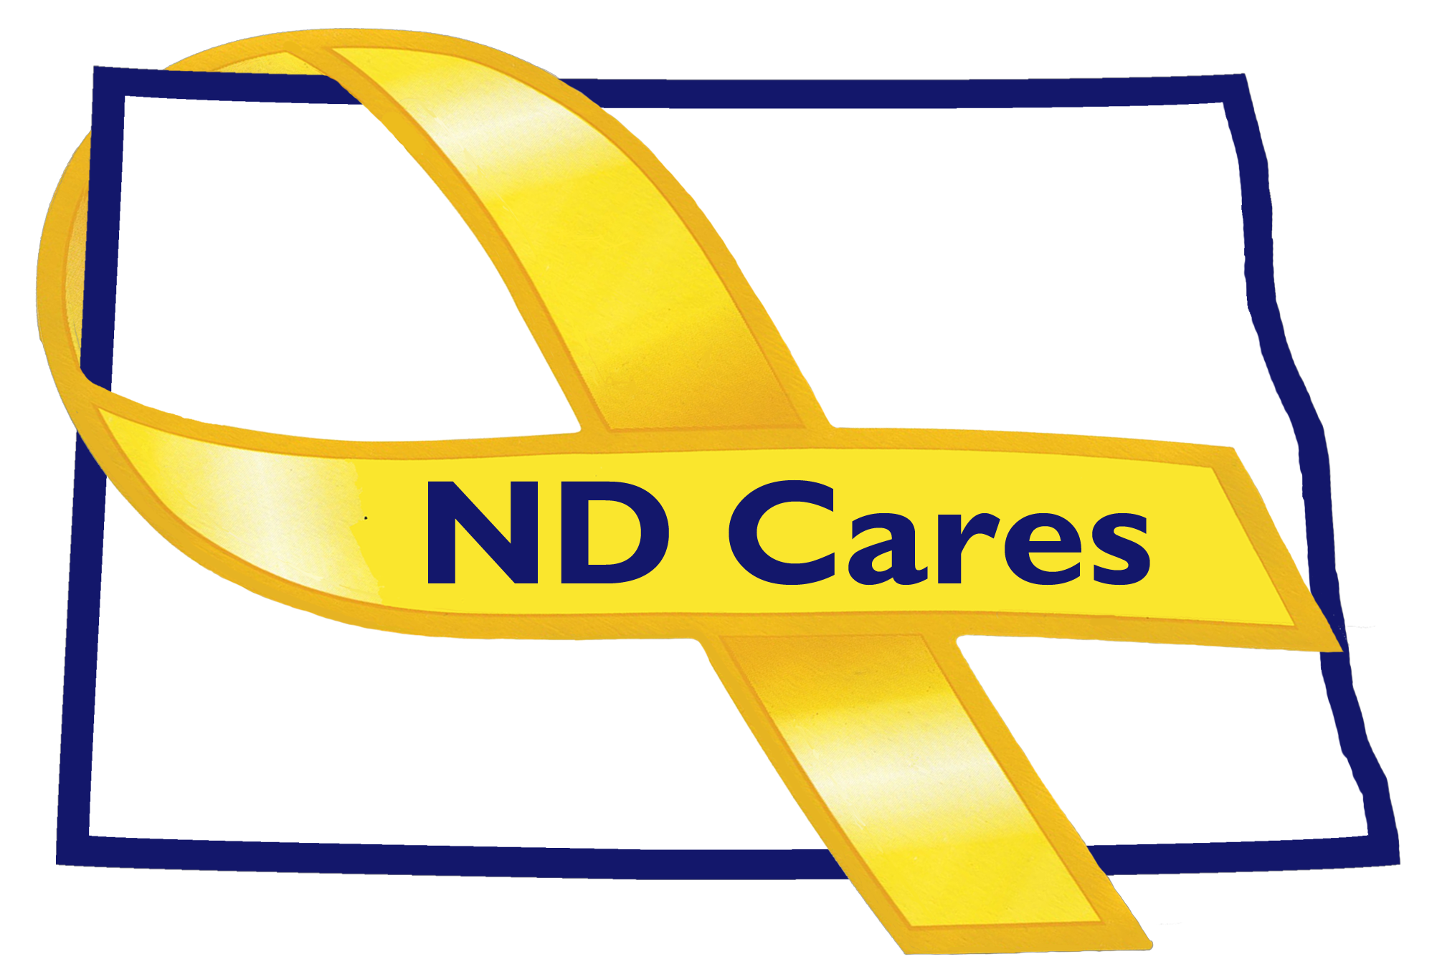
Oct 23, 2019

Attendees: Connie Sprynczynatyk, Dr. Breton Weintraub (Telephone), MG Alan Dohrmann, BG Jackie Huber, Cindy Whitesell (Telephone), LTC Pat Flanagan, Darcie Handt, Joe Faller

Absent: Joyal Meyer, Pam Sagness, Lonnie Wangen.

1. Minutes. Minutes from the August 21, 2019 accepted as written.
2. Due outs.
- No due outs to cover.

3. Old Business/Tasks Pending.
- Darcie discussed the proposed partnership with PyschArmor to create our own ND Cares page that would provide those training presentations, chosen by the ND Cares coalition, to be listed on our page for focused training relevant to our message. MG Dohrmann asked if this could incorporate relevant training to other areas like our current struggles in the state with flooding and farming. Feels this is something to think about as we move forward. Connie recommends we rely upon the communities to get the word out about this and other resources. Discussed adding video training developed by the NDSU Extension related to farm stress. A link will be added to the ND Cares website to reach the farm stress video training. Darcie discussed adding these resources to the Firstlink database to help support this effort. Darcie will put together a formal presentation, for the next meeting, to present what the PyschArmor relationship could look and feel like.
- Pembina was added as the newest community; currently 48. Darcie and Joe conducted, in person visits, with Turtle Lake, Garrison, Burlington, Grafton, Langdon and Pembina. Discussed how we are doing, what can we do better, other ideas about what is going on in communities. Burlington discussed their desire to build a Memorial. Grafton is also building a memorial, a 3D rendering of this can be found on the Walsh County Veteran Foundation facebook website. It is an amazing memorial. This information was given to the J5/9 for a future dedication event and to the NDNG historian for her support to the effort. Additional names were received from the communities to add to their steering committees. Discussed conducting site visits in the western part of the state in November. Will ask Maj Jay Sheldon to attend with us as the government affairs officer for the NDNG.
- Discussed the Community Clergy Training. Connie brought up the church bulletin from a church in Mountain, ND. The pastor, who attended the training in West Fargo, wrote an article for the bulletin. She requested we share the article with the Coalition. Looking to conduct a second training in the West either Medora or Dickinson. Currently looking at January 2020 dates requested by the VA.
- No updates to the business or community programs.
- The strategic plan; nothing significant to report.

4. New Business:
- Welcomed BG Huber to the coalition and Executive Committee. BG Huber will be the representative for the NDNG and MG Dohrmann.
- Discussed the change in membership between the outgoing USAR Ambassador Mr. Bob Black and the incoming Ambassador David Becker. Mr Black agreed that this change should occur and that he will submit his resignation letter to Darcie Handt for submission to the Governor. With the resignation letter ND Cares will submit a request to the Governor to appoint Dave Becker to the ND Cares Executive Committee. A motion was presented by Darcie, seconded by Cindy, and a vote was taken and approved by the Executive Committee to make this change.
- Nothing new to the website or facebook. Everything is working. Keep submitting items and events to be shared.
- The ND Suicide Prevention Coalition is an unincorporated entity. The ND Community Foundation relationship has been established so that they are prepared to receive money. January 22, 2020 will be the first annual conference. An invite to a breakfast to be held at the behavior health conference on Thursday November 14th will be coming. Miss ND will be there as her platform is suicide prevention. They are about advocacy, communication, collaboration and education. Working on their priority of efforts.
- Connie discussed when the next strategic planning workshop should be held. She said the current plan has moved along with the work of the staff and coalition partners. It is time to look at developing a new plan to support our efforts. Darcie recommended that we invite SAHMSA membership to participate in the workshop, not to facilitate the process. Darcie will submit a doodle calendar request, in November, to the coalition members for a date that works best for them. Connie reminded Bob Black that no matter where his resignation is, in the process, she would like him to attend this event.

- EC Members updates:
  - Cindy spoke with individuals at the MAFB, they are currently supporting the Air Force efforts to train individuals on suicide prevention. Discusses how the Air Force is dealing with drug problems but not at the MAFB. As with much of the state, there is a concern of alcohol consumption. Tomorrow is the Minot Standdown. Darcie let Cindy know that he will be in Minot tomorrow to meet with the Dr at the MAFB that supports/decides if Airman come to the MAFB based on their and family medical needs.
  - Darcie talked about the Commissioners Challenge; currently 311 individuals have viewed the video. We do not have a count of those who have viewed it on YouTube. Lonnie continues to reach out to state entities to support this initiative.
  - Brett; the Fargo VA suicide prevention is their number one effort to support.
  - The Department of Health is hosting a meeting about the student loan repayment program and how useful it is by doctors and mental health providers. One statistics is that 87% retention rate after completing the student loan repayment program.
  - Pat brought up the Main Street Summit, next week, which the Surgeon General will be in attendance for the 3 days. BG Huber is scheduled to attend this event.
  - Discussed either Connie or Darcie should reach out to Pam to decide who will be Behavior Health division representative do to their current structural changes.
  - Behavior health conference is scheduled for November 13-15. Recovery Reinvented is scheduled for November 12th. Both events will be held at the Bismarck Event Center. Connie recommended we look at the following week for our strategic planning meeting.
  - LTC Flannagan discussed the NDNG efforts to establish MOU’s to support behavior health. Signed MOU’s with the Human Service centers; 7 planned ASSIST trainings scheduled. The MOU with the Department of Public Instruction is written and currently in the review stage. Working to schedule training with First responders. Working to broaden their partnership and prevention program. The Army resiliency training program has a copy write; so they are working with NGB to see if they can expand this to others. NGB has moved away from ASSIST trainers and now leave it up to the states for participating. Connie recommended reaching out to the Police and Fire chiefs association for expanding to first responders. The CR2C, or former CHPIC, the NDNG is working to recreate the Commanders Readiness and Resilience Council. Reminded everyone of the NDNG Halloween event this coming Monday. Talked about the transition away from contract to federal Title 5 positions for the Family assistant and Family readiness positions creating long term stability in these positions. Discussed his transition on January 1st and Sean Flemmer will be replacing him.
- MG Huber discussed the current weather impacts to the state of ND and the NDNG.
- Bob Black did not have anything to add.
- Connie discussed our partnership with the National Veterans Intermediary and their training today supported by their partnership with the National League of Cities. Training today is called Applying an Ecosystem to Serving Veterans in your City. Some of these events are shared with the coalition members for their attendance. Next Executive meeting may change from the schedule depending on the date of the strategic planning conference.

5. Upcoming events:

  - North Central Veterans Stand Down, Minot, October 24th, 2019
  - Recovery Reinvented, November 12th, 2019
  - Behavioral Health Conference, November 13th – 15th, 2019
  - ND Suicide Prevention Coalition Annual Conference, January 22nd, 2020

Respectfully submitted,

Darcie Handt, Executive Director

