ND Cares Executive Committee Meeting
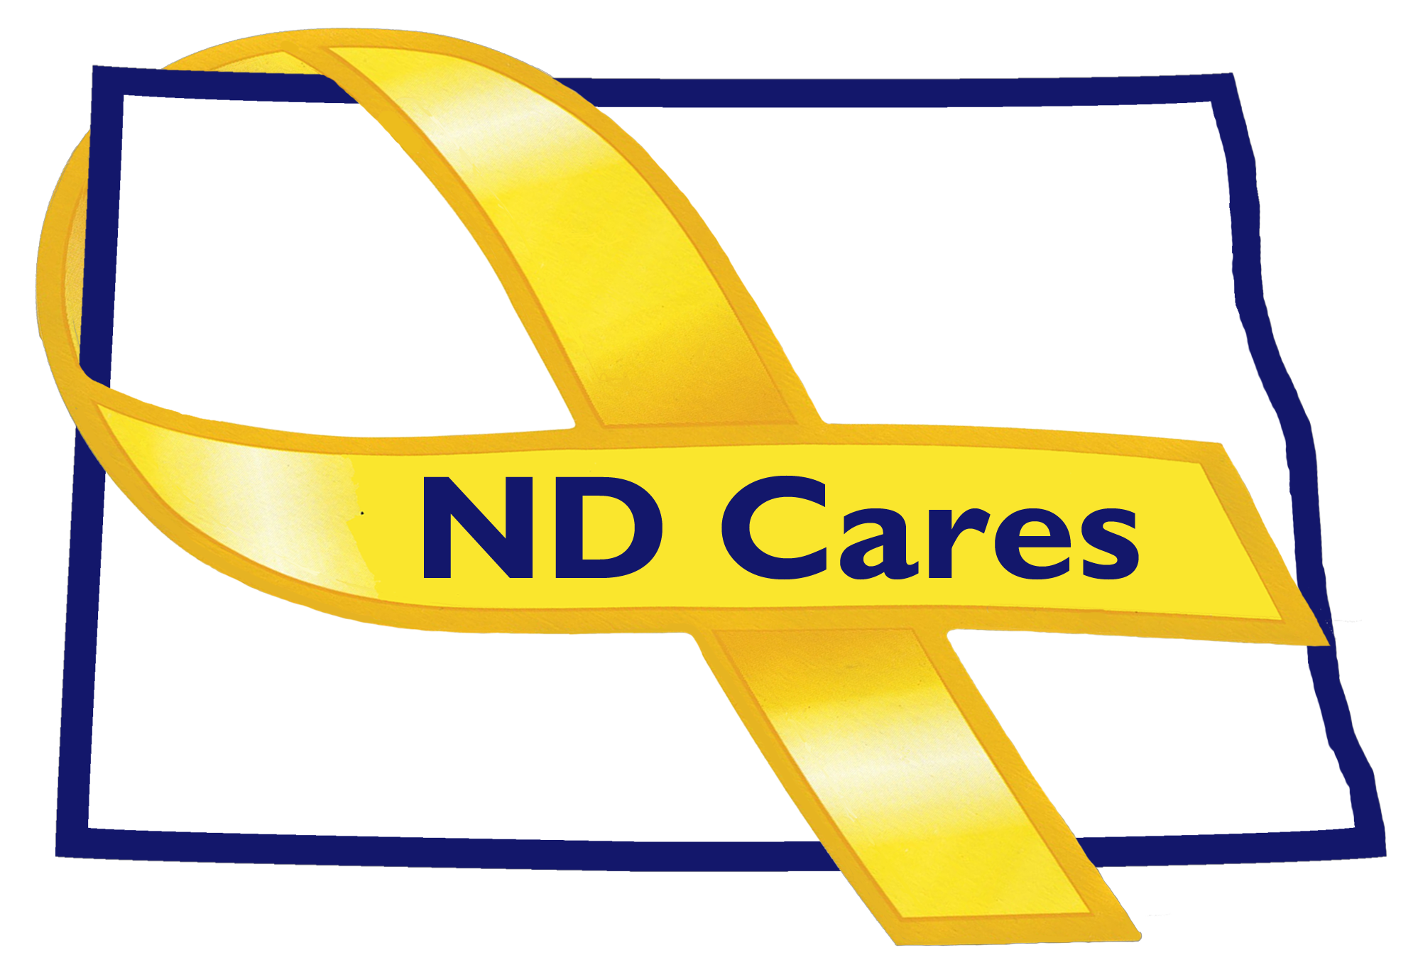
June 4th, 2020

Attendees: Connie Sprynczynatyk (virtual), Dr. Breton Weintraub (/virtual/Telephone), Pam Sagness (virtual), Joyal Meyer (virtual), MAJ Shawn Flemmer (telephone), Lonnie Wangen (virtual), Cindy Whitesell (virtual), Davina French (virtual), Brian Waters (virtual) David Becker (virtual),
BG Jackie Huber, Joe Faller, Michelle Panos.

Absent:
1. Opening. Connie opened the meeting.

2. Minutes. Minutes from the February 6, 2019 meeting where accepted as written.

3. Introductions. Michelle Panos, the new executive director, introduced herself and her background,
then each Executive Committee introduced themselves and explained their positions.

4. Do Outs
- Michelle explained that the action plan development for strategic objectives will continue, progress will be reported out, and changes will be made as necessary to focus on specific areas given the reduction in staff. It will be a work in progress.
- Finding a research partner with another entity on executing a Business Summit will be put on the back burner due to restrictions due to the COVID-19 pandemic.
- Joe Faller spoke about the work to research University/College level in-service requirements as opportunity for integration of military culture will continue. Continue engaging with Minot State and NDSU where we already have a business relationship. Then hopefully work with the Tribal College in the same manner.
- Connie briefly mentioned that Dan Donlin is a perspective contact for community Chaplaincy and we will continue our efforts to partner with the faith community.
- Joe reported out the results of the trips to Minot and South Dakota.

5. Old Business
- Joe Faller gave an ND Cares Business Update stating that the current number business remains at 19.
- Joe also discussed the status of the ND Cares Community Reconnect Program. Since last meeting the number of community to be revisited remains at 10 out of 48. The COVID-19 pandemic has halted those visits, however with more entities opening again, visits will resume this summer.
- Connie mentioned ND Cares ongoing relationship with First Link and asked if any member had a question or issue about it – there were none.

5. New Business
- Gen Huber, David Becker and Joyal Meyer all acknowledged that they received their notice of appointment to the executive committee by the governor’s office.
- Joe Faller stated the ND Cares currently only has website and Face Book, we can look at other social media platforms in the future.
- Joe reported that Grant Larson is still working on regionalization of efforts and associating with Beyond the Yellow Ribbon in Minnesota and Moorhead and match those effort with those of ND Cares in Fargo and West Fargo. We will schedule further contact.
- Joe also discussed the Suicide Prevention Coalition. He understood that Darcie was heavily involved and assumed that Michelle will continue the relationship in some capacity.
- The committee discussed and decided that another executive committee meeting prior to the next coalition meeting was not necessary. In addition the committee decided the July 9 meeting will be held virtually due to the COVID-19 pandemic and be limited to 2 hours.
- Each committee member provide an update.
6. Closing: Connie closed the meeting around noon.

