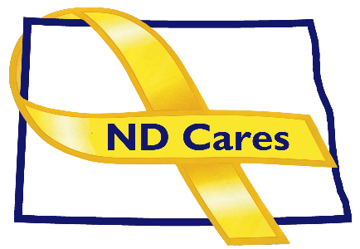
ND Cares Executive Committee Meeting Minutes
July 6, 2023

Attendees: Shelly Sizer, Dr. Weintraub, BG Jackie Huber, Lonnie Wangen, Joyal Meyer, LTC Ann Willoughby, Michelle Panos (All virtual)
Absent: Cindy Whitesell, David Becker, Pam Sagness

1. Opening. Chairman Shelly Sizer briefly opened the meeting.

2. Minutes. Minutes from the May 4th meeting were accepted as written with one correction.

3. New Business
- Executive Committee Updates
  - Chairman: Shelly reported on her May CASA meeting and her coordination with the Midwest regional director for Soldier for File, LTC Ginn. Shelly scheduled an August 1st meeting to discuss reinstating the program in North Dakota.
  - NDNG: BG Huber talked about the Military Police company that will return from Kuwait this month and another company going to the southwest board for 30 days in August. We already have people on the southwest border that will be coming home just when another will arrive at the border. The Guard is busy planning the Women’s Leadership Summit on Aug 3, in Fargo. The American Ambassador to Togo is one speaker. LTC Willoughby talked about the Service Member and Family support Facebook page and suggested following the page to receive updates on activities throughout the year. There is also CALM Training at RJB Armory on August 8th and other events happening soon including Yellow Ribbon events.
  - NDHHS, Health: Joyal gave an update on the Suicide Prevention Coalition Conference scheduled for Sept. 14 at the Career Academy at Bismarck State College.
  - NDDVA: Lonnie reported on the completion of the FOX Grant application what will award $750,000 for veteran suicide prevention efforts in the state. He completed it with help from Human Services and FirstLink, ND Cares and the UND. Lonnie also talked about ordering the signs for all the bridge dedications coming up but for the Hidden Wounds bridge we don’t put anybody’s name on it, just something about 988. He is hoping to set up a nomination process for naming future bridges.
  - Regional VA, Fargo: Dr. Weintraub reported that recruiting remains an issue, however they have made some progress. Their c current roster is higher than at the start of the period, but there are a lot of open positions. The OIG recently chose the Fargo VA as a test facility for inpatient health inspections – they did well with just a couple of helpful suggestions. Dr. Weintraub attended a senior leadership meeting in Phoenix where VA officials reaffirmed that mental health is a strategic initiative and there is strong support for it. For PACT the Fargo VA has screened over 50% of veterans. Lastly, Dr. Weintraub stated that he accompanied VA and Fisher House officials to look at the several parcels of land and hopefully they can acquire the preferred one.
4. Old Business
- Michelle reported that the number of communities remains the same, but ND Cares will add Dakota Home Care in Mandan and Fargo as a business partner August 9. Shelly confirmed she can attend. For the Governors Challenge update Michelle talked about intern Jonathan Ross and his work to provide a data dashboard for internal use and external presentation. She talked about what the team learned at the Innovation Conference and the Implementation Academy. Kristy Johnson, who headed the state Peer Support program has left her position and Heather Brandt is temporarily stepping in. She has contacted Together with Veterans to talk about a train the trainer approach and will ask the First Lady if she could talk about the importance of peer support at the upcoming Recovery Reinvented. Michelle also reported the NDNG will pay for mental health providers to attend the STAR Behavioral Health Providers training program that is a 3-tiered military culture and treatment training. It is free to participants and includes CEUs. In addition, Dakota Home Care requested military culture training for their 160 field staff. Lastly Michelle reported the Governors Challenge Team is working closely with UND on their CDC grant activities including collaborating on dashboard data. Jonathan will have a mockup of a dashboard in time for the SAMHSA/VA site visit in August.

5. UPCOMING EVENTS

Of the listed events the group further discussed the Women’s Leadership Conference and the
CALM training.
- NEXT MEETING DATES

The next Coalition meeting date is September 7th and the next Executive Committee meeting date is August 3rd.

