ND Cares Executive Committee Meeting
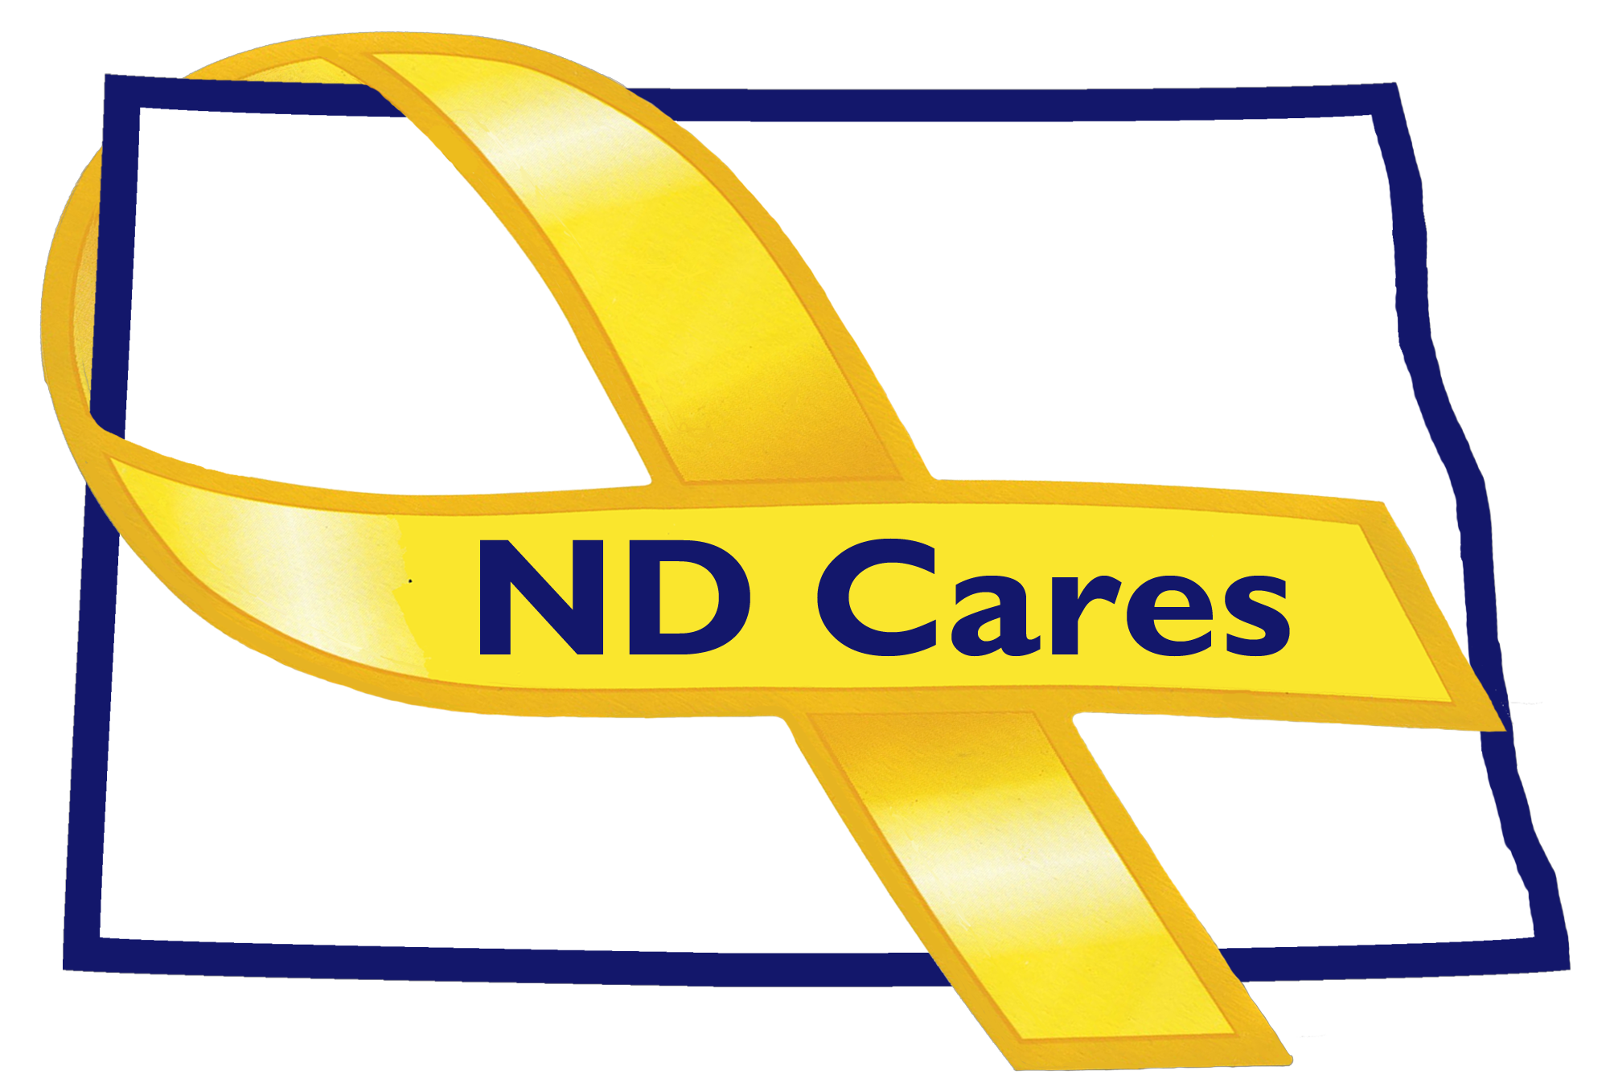
April 24, 2019
Draft

Attendees: Connie Sprynczynatyk (Telephone), Lavonne Liversage (Telephone), MG Alan Dohrmann, LTC Pat Flannigan, Davina French, Robert Black (Telephone), Cindy Whitesell (Telephone), Brian Waters (Telephone), Darcie Handt, Joe Faller

Absent: Pam Sagness, Joyal Meyer, Lonnie Wangen

1. Minutes. Minutes from the February 24, 2019 accepted as written.

2. Due outs.
- Community conference calls are not well attended, but we did have two businesses on the recent call and discussed how they are caring for their military members, Veterans, and families. Also, connected two businesses to work together to further develop their program. We will work with these businesses to highlight their progress and to highlight the events/mentorship they conduct.
- Met with Dave Klein with the Great Plains Housing Authority. Discussed items that they can help with, through the ND Housing Coalition, to help support SMVFS. Discussed their current housing initiatives and how to increase capacity. Also discussed possible partnerships; who may be able to assist him with his initiatives.
- Get Tag-Alongs for next meeting

3. Old Business/Tasks Pending.
- Gate City Bank newest business; currently 17.
- Met with Kalix and Strata Corporation in Minot. Businesses currently looking to support ND Cares events include; BCBS North Dakota, Xcel Energy, Sysco Foods, & Fortis Energy.
- Newest Community is Argusville; currently 47.
- The strategic plan; goal #1 update – Darcie will pull First Link Data in May to help update and populate their database. Updates are made in May and October. Goal #2 update; ND Cares is on social media; pull together metrics on website and Facebook for next meeting. Please update us when you hold engagements with stakeholders. Adding military culture to college curriculum. Added to Minot State University working with NDSU and UND. Learned that the Bismarck Vet Center is conducting Military Culture Training at the University of Mary. Completed two metrics slides for the TAG update brief. MG Dohrmann asked we ensure the PAO is up to date about our events; also discussed the new TAG Line newsletter. Darcie advised that we have provided an article for the TAG Line and also are scheduled to present during an upcoming professional development.

4. New Business:
- No new members to the Coalition. LaVonne will be retiring on June 8th and Dale Dekrey will be the interim administrator. We wish you the best; it has been fabulous working with you.
- The new State of North Dakota ND Cares website is almost complete. Working with the Commerce Dept for the logo. Also need to create a map to list our ND Cares Communities.
- Darcie discussed his meeting with Alison Traynor, Kora Dockter, and Dr. Michael LeBeau (Sanford), and that they (Sanford) will be implementing Zero Suicide. Will be meeting, next week, with a representative from the National Zero Suicide program. Want to ensure we are advising Sanford correctly. 3 big asks; Training at the intake level; follow on care planning; entering at risk patients in a call back system. Discussion continued about access and whether the issue is capacity or insurance coverage issue to Behavior Health Services; we feel it is both.
- Fargo ND Cares training is scheduled for May 22nd. Will be held at the West Fargo VFW.
- Darcie talked about the new radio/tv ads that will be run through the Broadcasters Association contract. ND Vets Home and Firstlink will be the new ads to be run during the new biennium. Will be going to Minot at the end of the month to be part of a radio station podcast.
- EC Members updates:
  - Davina talked about the Peer Support training and that she and Corean Swart will be attending. TAPs is upcoming at the end of May. MG Dohrmann discussed changes coming to the National Guard Foundation and the Office of the Adjutant Generals office ability to fund events like these as authority was given during this legislative session to assist with these events.
  - Cindy talked about her replacement, John Jeziorske, he is a retired military from the mental health office, was the mental health officer. Cindy connects with John and Ms Gram after executive meetings. No objections to adding John to the coalition.
  - Bryan talked about the idea/challenge from the NDDVA commissioners to get organizations to commit/complete the online SAFE training. Organizations being considered are State, County, City and Federal offices, Churches, Non-profits and others. Looking to get corporate sponsors. Currently asking for input on this challenge. Working on Clergy training on PTSD in ND. VA tele-mental health; tying in Veterans to the VA. Working on a grant to fund high speed internet to facilitate tele-med in rural areas. Discussed possible corporate sponsorship with ND Cares Businesses to support initiatives.
  - LaVonne; Outreach event at the GF Air base tomorrow. Working on training the staff on the Mission Act – Implement by June 6th. More than 50 sections to the Mission Act. Major component is the Care in the Community Act – eligibility criteria expanded. TriWest is the third party administrator for the Care in the Community. Expansion of the Care Givers Eligibility; new Urgent Care Benefit; increased opportunity to expand staff; lots of work to be done. The 90th Anniversary, discussed in previous meetings, has been scaled back. Discussed having the VA brief Mission Act changes to the ND Compass group.
  - MG Dohrmann; nearing the end of legislative session. Appropriations was signed, received authorization for the third Social Worker. Received the ability to accept funds to execute SMFV state events. Two events currently are the Youth Camps and TAPS/Remembrance weekend.
- Robert Black; nothing to add.
- Connie; mentioned that Mr Black is now an emeritus status as the Army Reserve Ambassador. New ambassador is David Becker. Works for the ND Dept of Human Services as a Compliance Officer. Will schedule a meeting with him to discuss future participation. Wants to discuss further information she received in Texas about Veteran Courts.

5. Upcoming events:

- Peer Support Training, Bismarck, May 6th – 10th
- ND Cares Coalition Meeting, Bismarck, May 9th
- ND Cares Community Training for Region 5, Fargo, May 22nd
- VA Mental Health Summit, Minot, August 22nd

Respectfully submitted,

Darcie Handt, Executive Director

