ND Cares Executive Committee Meeting
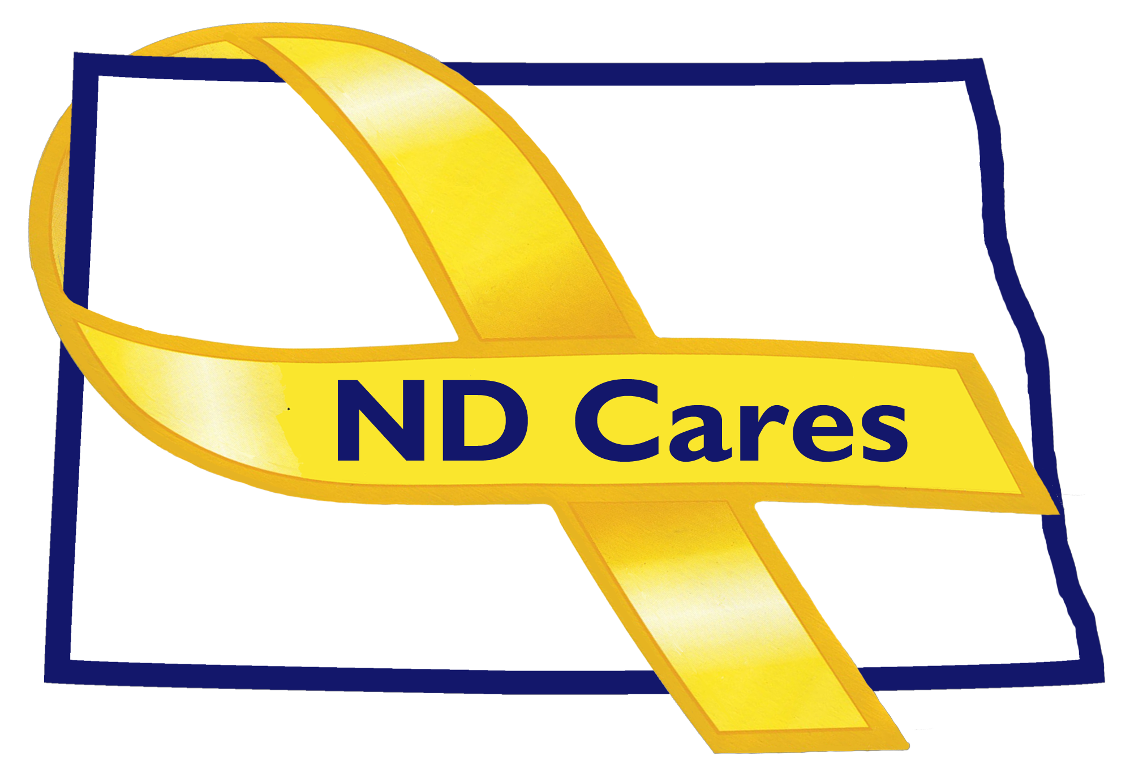
December 4, 2018
Draft

Attendees: Connie Sprynczynatyk, Cindy Whitesell (Telephone), Brig Gen Dohrmann, Lonnie Wangen (Telephone), LTC Pat Flannigan, Alison Traynor, Bob Black (Telephone), Bryan Watters (Telephone), Davina French, Darcie Handt, Joe Faller

Absent: Pam Sagness

1. Minutes. Minutes from the September 13, 2018 accepted as written.

2. Due outs.
- Very little information from Soldier for Life. A brochure was provided from the organization when information was requested by Joe.
- Dept of Commerce Representative will be Bonnie Malo.
- ND Cares Databook draft hard copy was provided. Request a quick response to any required changes. DOCR information was deleted at the request of Lisa Peterson due to possible inaccuracy to information. Thank you Amy for your work on the Databook.

3. Old Business/Tasks Pending.
- Please continue to send information to be posted to the ND Cares website and Facebook.
- Currently 46 communities; recently added Lincoln. Kelli Weiand, Darcie and CVSO are working with the Grand Forks community to become the regional support network.
- BCBS is looking to conduct Military Culture Training. BCBS held their Veteran appreciation event. Starion Bank helped support the Bismarck Standdown. Fortis Energy is supporting a turkey bingo in Minot; proceeds will go to the local Vet Center. Coca Cola High Country helped support the Minot Standdown. Edgewood in Bismarck is looking to conduct a fund raiser and is looking to help support a local Veteran Charity. Benchmark mortgage is looking to do a statewide fundraiser for Veterans. Darcie asked where the committee would like us to refer businesses when they want to support Veterans and their organizations. Connie recommended creating a list to help guide these businesses if they do not have a specific place in mind. Lonnie reminded the group that on his website is Vetted organizations under the Support Veterans tab. Connie asked that we begin a rotating display on our website and facebook of photos; yes, photos are needed. Darcie will request photos from the BCBS event.
- The conference call on October 18th had little attendance.
- Goal 1, of the Strategic plan, was to create a single resource hub. Firstlink was chosen to be used for this goal. Information has been provided to Firstlink and they are verifying the data provided by the Secretary of State and adding these businesses to their site. Semi-annual reports of increased business, added to Firstlink, is being requested by Connie.
- Goal 2, Darcie has conducted two Military Culture Training classes to Minot State University course of studies. Darcie will be meeting with University of North Dakota to look at conducting the training to their students. Connie asked about Jamestown University and the University of Mary as Business partners. We have reached out to U of M, but not to Jamestown, an effort will be made to them. Darcie conducted a leadership training with the NDSU band.

4. New Business:
- Approval from the Executive Committee to add Bonnie Malo to the coalition. No objection voiced. Bonnie will be added to the coalition. Nicole Berman, Behavioral Health Division, to be added to the Coalition. No objection voiced.
- EC Members updates:
  - MG Dohrmann; briefed the NDNG legislative initiatives. Also discussed his NDCOMPASS priorities. Discussed the Governor’s Task Force on delivery of Veteran Services; not an effort to change but to improve Veteran Services.
  - LTC Flannigan; the NDNG will continue to train the ASSIST program to outside entities along with National Guard members, dependents and volunteers. ND Cares purchased ASSIST training packets that will be used to support these trainings. Prime for Life targeted bases training, if a member gets a DUI, this training will allow members to offer this training to service members if Soldiers get in trouble for a DUI. These trainers will be certified to conduct this training.
  - Lonnie; briefed the ND Veterans Legislative Council initiatives it will be bringing forward to the Legislature.
  - Cindy; Minot Air Force base has announced her replacement and a new Violence Prevention Integrator, she would like to invite these individuals to the coalition meeting.
  - Davina; thanked the VA for their effort on their first woman’s Veterans event. They did an outstanding job on this effort. Her last day in the guard is Friday Dec 7th.
  - Bob; no update.
  - Alison; her position is moving to the Behavioral Health Division. Membership in the EC will be decided by the leadership of the Behavioral Health Division. Working on a State wide meeting for partners (Jan 16th). ND Suicide deaths are increasing, some of this may be caused by change in reporting of deaths but not to the extent that suicides have increased.
- Darcie; attended the Multi-State Learning Consortium meeting in Clearwater FL. The topic dealt with occupational licensing and licensing process. Lots of effort being made to streamline the process.

5. Upcoming events:
- The next Coalition meeting is the afternoon on Jan 24th.
- ND Cares Legislative Day Jan 25th with booths from 0800 – 1300. The 15 booth assignments have been completed.

Respectfully submitted,

Darcie Handt, Executive Director

