ND Cares Executive Committee Meeting
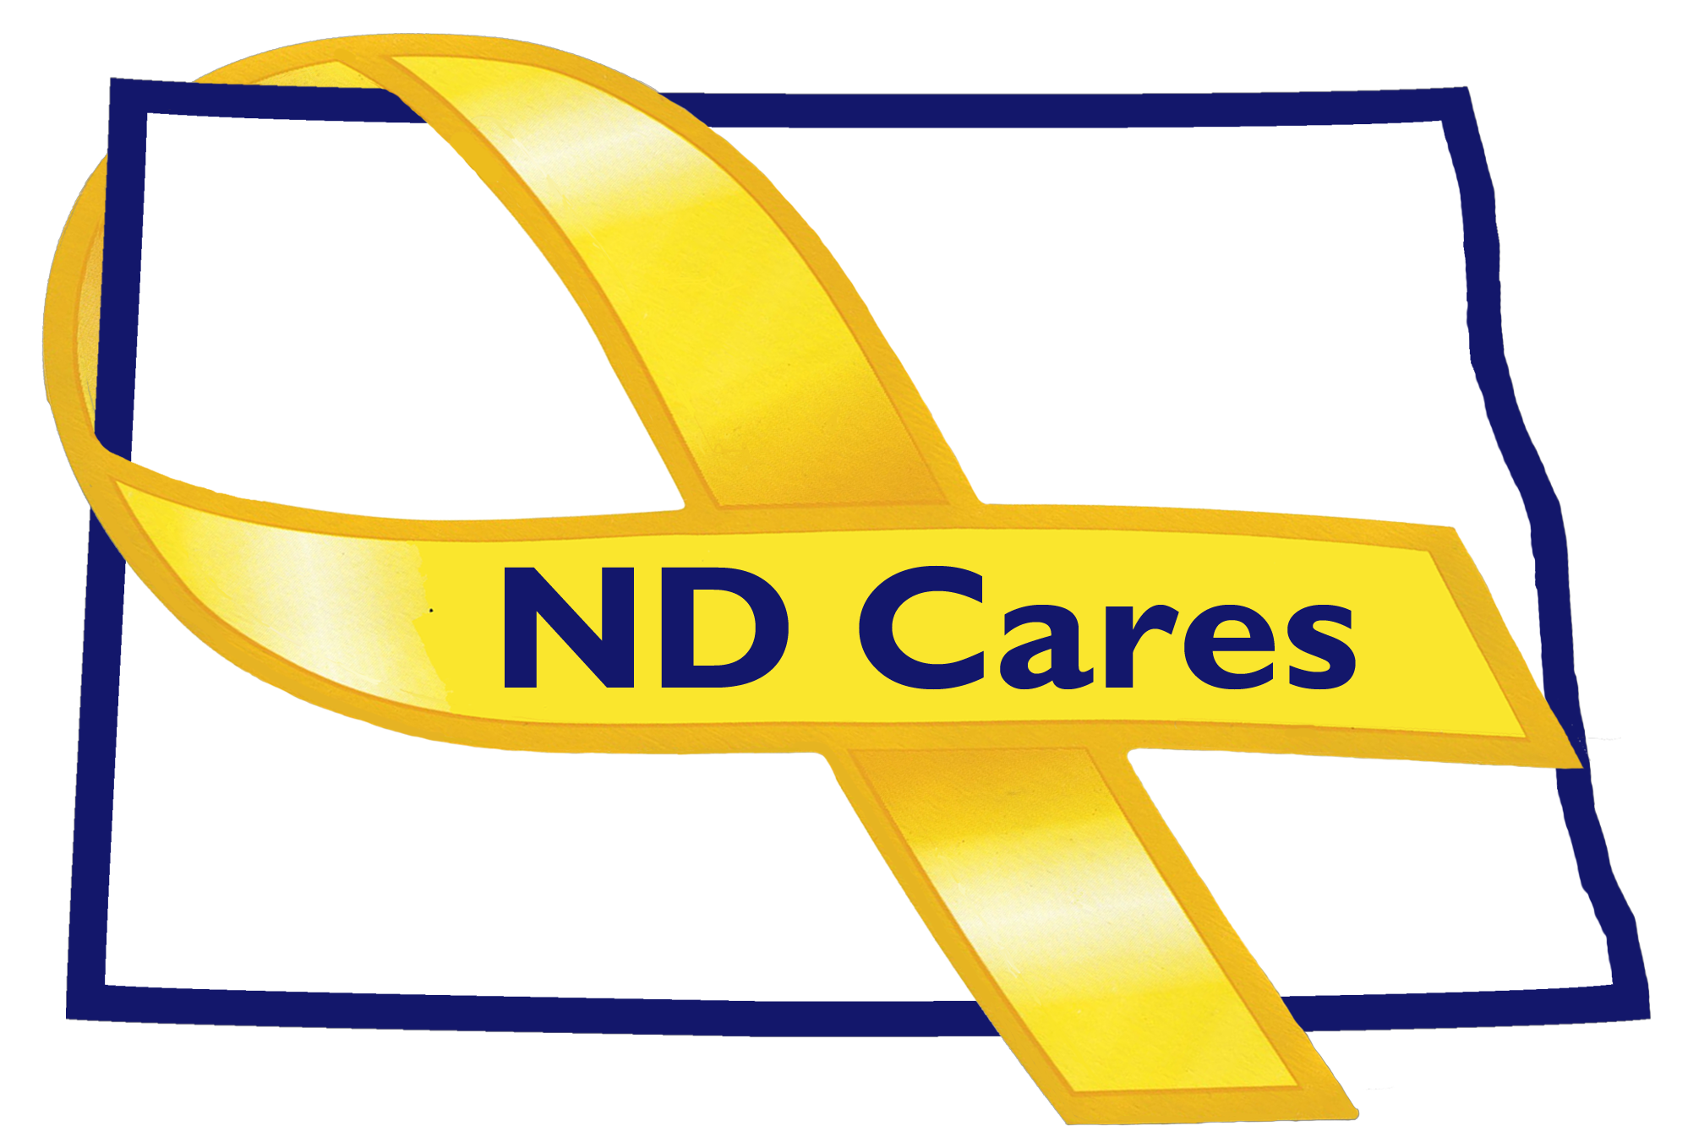
February 28, 2018

Attendees: BG Becklund, Alison Traynor , LaVonne Liversage (Telephone), Bryan Watters (Telephone), Darcie Handt, and Joe Faller (Telephone).

1. Minutes from the January 3, 2018 meeting will be addressed at the next meeting. No quorum.

2. Old Business/Actions since previous meeting

- Changes have been made to the ND Cares website. Please visit the site and let us know of any recommended improvements.
- Currently 40 communities. Finley is the most recent addition.
- A new TBI Awareness Month radio advertisement will begin running soon and continue through March.
- Currently have 9 ND Cares Businesses and continue to make contact with others. Recently added Blue Cross Blue Shield ND who will be supporting us with $2500. Received $2000 from National Veterans Intermediary for becoming a member with their group. Darcie will send an email to the Executive Committee Members to provide options to facilitate donations. Will follow up with Sanford and St Alexius CHI. Will need to develop a spending plan for donations and receive Executive Committee approval.
- The second newsletter is scheduled to go out in March. If you have an article you would like to share or event you would like to highlight in any upcoming newsletter, let Joe know.
- Strategic plan goal #1. Working to get names for the working group. Have discussed this with ITD for their support. Will use them wisely as we get 6 hrs of time for free and will be charged for any additional time. Firstlink and Heartview have agreed to be part of the working group. Goal #2, working regions #5 and #8 to discuss regional issues. Had a meeting in Dickinson last week; will begin working on a training plan for that region with input from other Region 8 Network members. Have contacted the University of Mary and Minot State University about adding Military Culture to their curriculums. OBJ 2.5, Joe is working this with Jenn Anderson from the NDNG and Ross Tweten from the Fargo VA.
- Notes from Pat Flannagen, Jeff Hoffer was reassigned to recruiting so the Resiliency Position is open along with a Victim Advocate Position. Bismarck Community Fitfair is scheduled for Aug 25th, 2018 at the Bismarck Bowl. MDU is now the lead sponsor for the event.

- New Business

- New coalition membership, David Francavilla is replacing Veronica Patrick with the Veterans Experience Office.
- NDDVA has scheduled the next ACOVA meeting in Watford City on May 10-11. CVSO state meeting is March 19-21 in Bismarck.
- VA updates; Bemidji and Grafton are opening new clinics. Next town hall is March 15th in Fargo. Other open houses are planned throughout ND. New contracts are signed for Williston and Dickinson clinics.
- Alison updates; hearing about needs for training across the state. Trying to utilize funding to facilitate as much training as possible. Will be discussing with the HSC Clinical Directors to talk about an opportunity to collaborate to provide an evidence based clinical Master train the trainer. Continue with Sources of Strength in schools. Working with Game and Fish to present evidence based training in different events and opportunities.
- BG Becklund; the use of the National Guard is not going down so he feels the relevancy of ND Cares will continue to grow. National Governors Association was in D.C., good interaction between Gov Bergum and the Chief of the National Guard Bureau.

- Upcoming Events

ND Cares Coalition Meeting - May 9th 2018
Executive Committee Meeting – April 4th 2018

Respectfully submitted,

Darcie Handt, Executive Director

