ND Cares Executive Committee Meeting
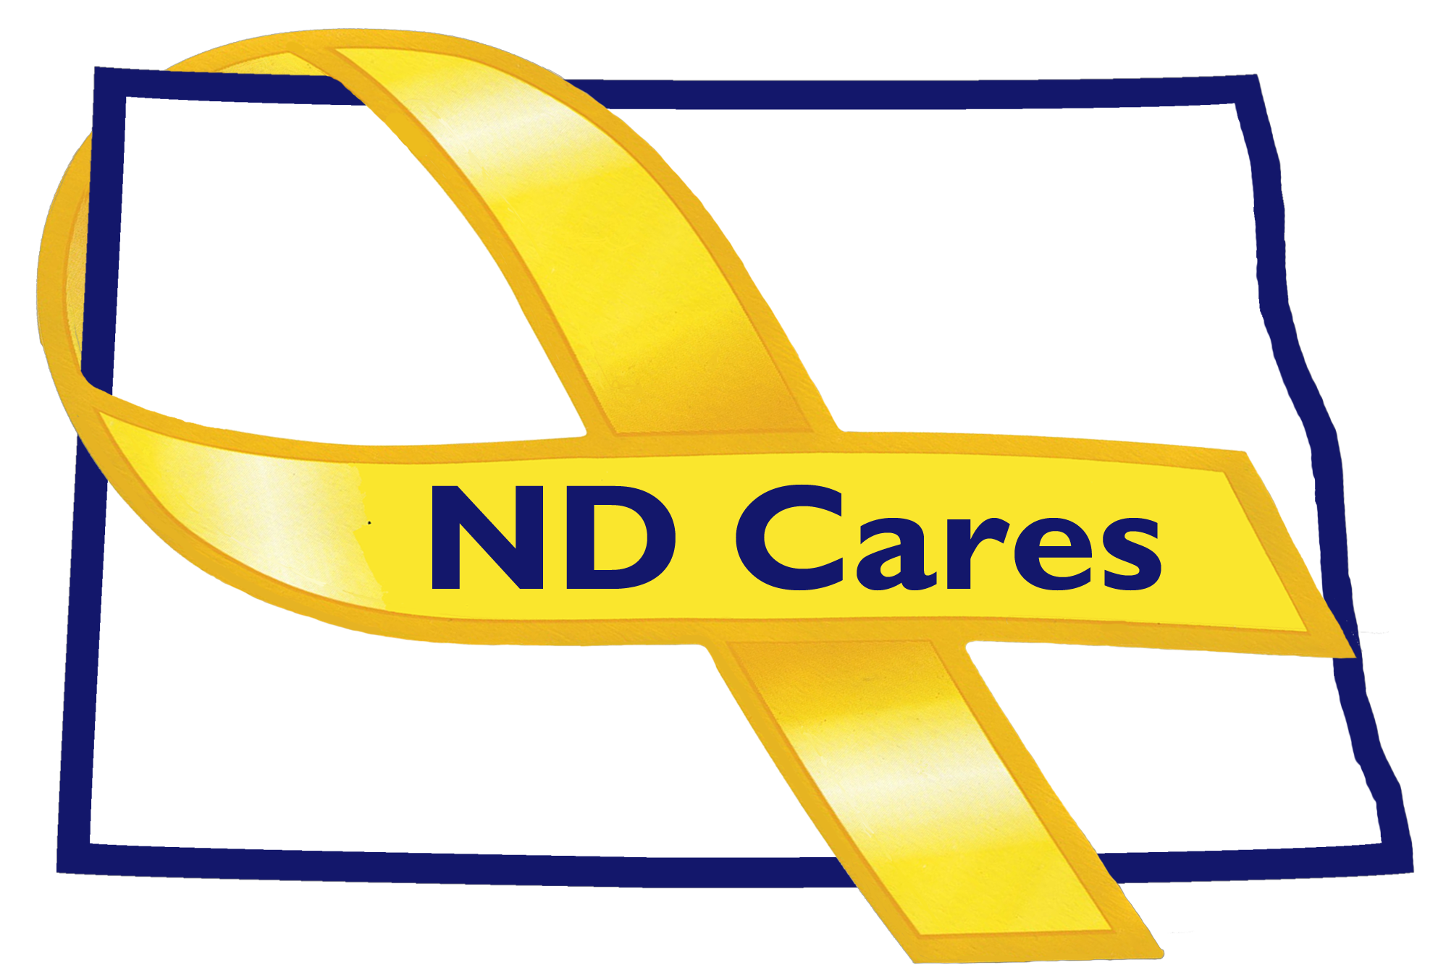
January 3, 2018

Attendees: Connie Sprynczynatyk, MG Alan Dohrmann, Alison Traynor , Cindy Whitesell (Telephone), LaVonne Liversage (Telephone), Robert Black (Telephone), Davina French, Pat Flannagan, Darcie Handt, and Joe Faller.

1. Unanimously approved minutes from the November 14th, 2017 meeting as written.

2. Old Business/Actions since previous meeting

- Joe briefed that changes to the website are being made, an email will be sent when complete for member to review. Joe will provide an analytical report of recent usage to committee Members.
- Currently 39 communities. Lisbon is the most recent addition.
- Darcie briefed we are 6 months into the PEP Program. ND Cares has spent $40k and have received over $100k in advertising in the first three months of the contract. He also briefed we have received our second good news story from the Firstlink ads. A woman was contemplating suicide, with a weapon nearby, when her husband walked in, heard the ad, and had her call for counseling. Showed the first ND Cares Newsletter and was provided guidance that we should provide these quarterly.
- Currently have 7 ND Cares Businesses and continue to make contact with others (Gate City Bank, Sanford). Recently received an email from Xcel Energy that included their intent to provide a donation as part of the Business Initiative. Will continue to work the process for receiving funds and how to execute those funds.
- Connie asked members if there were any recommendations to the developed strategic goals and objectives. No recommendations. Objective 2.5 is assigned to ND Cares staff; social media used will be based on where our audience is. Went through the remaining objectives and recommended working group members. Objective 1.1 recommended work group members are: Firstlink, Hearview, NDVA, ND Human Services, VA Outreach Representative, ND Suicide Prevention, County Veterans Service Officer, and ND University System. Recommendation was to conduct individual engagements to find out what is there and then strive for a willingness to collaborate. Objective 1.2 would include the same individuals as 1.2 but also add the ND State IT Department and the ND Commerce Department.
Objective 2.1 is very inclusive and will require multiple partnerships and will require a starting point. This could be different for all eight regions and may require additional staff involvement. Discussion about each region and their strengths. Recommendation to contact Sherri Adams, in the SW region, to link with her groups already developed. The staff will need to be the driver of this objective. Objective 2.2 will come out of the work of objective 2.1 and will require a group effort. Staff will continue to work with the University of Mary and Minot State to incorporate Military Cultural training into university curriculum coursework.
- New Business

- Shared the NDDVA Coin that will be presented to a family member of a deceased veteran.
- VA updates; would like ND Cares to continue to share their events. Three new CBOC’s will be opening soon.
- Suicide Prevention Coalition event will be held on January 17 at the BSC Career Academy.
- Climate assessments are being conducted at the Minot Airforce base. Partnering with Bottineau Winter Park for a Military Appreciation day on January 15.
- The NDNG’s Suicide Prevention, Resiliency and Risk Reduction positions have been filled. Working on legislative initiatives for the upcoming legislative session. Recommended to add legislative issues to the April Coalition meeting agenda.
- Davina asked the VA to provide updates to the VA Caretaker Committee initiative working its way through the Federal VA program.

- Upcoming Events

ND Cares Timeline review

Respectfully submitted,

Darcie Handt, Executive Director

