ND Cares Executive Committee Meeting
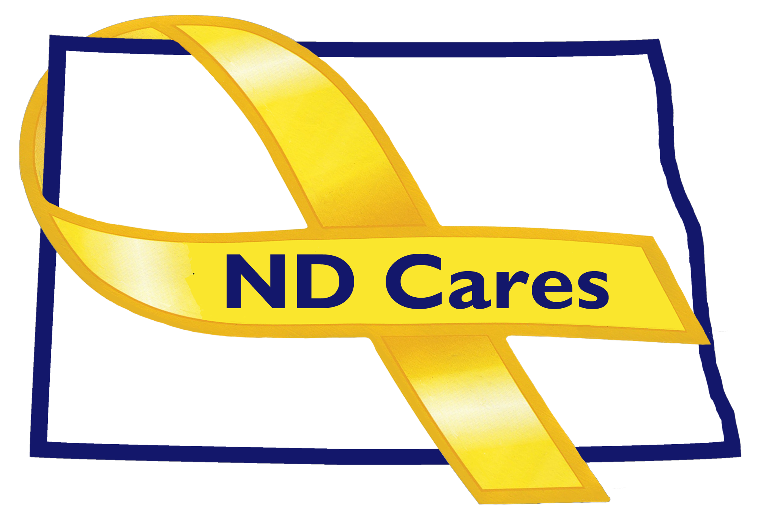
July 25th, 2018

Attendees: Connie Sprynczynatyk, Brig Gen Becklund, Alison Traynor (Telephone), Bob Black (Telephone), Pam Sagness (Telephone), Bryan Watters (Telephone), Davina French, Darcie Handt, Joe Faller

Absent: Cindy Whitesell, LaVonne Liversage

1. Minutes. Minutes from the April 4, 2018 accepted as written.

2. Old Business/Tasks Pending.
- Facebook is up and running. New information and events are posted on facebook.
- Website usage report was provided; question was asked about the definitions on the Google Analytics report, specifically the acquisition of user’s definition. Joe will provide the definition as part of the meeting minutes(see below) and send to Executive Members. Darcie discussed a conversation he had with MG Dohrmann about the website value and where it resides. The discussion included the Governors desire to bring state websites to one portal for users ease of use. The board members agreed we will continue to manage the website where it is now until the state provides guidance on possible migration of all state websites. Joe will check with ITD on adding a link to the state webpage to ndcares.org. Bryan will add a link to the NDDVA website to ndcares.org and Joe will add a link to the NDDVA website.
- Currently 44 communities; recently added Wahpeton.
- Darcie briefed the enduring campaign with the ND Broadcasters Association is going well. Recently added an ad, with consent of Henry Gerving-CVSO, guiding individuals to contact their CVSO which can be done by contacting FirstLink who will guide them to their local CVSO. NDDVA is also using the ND Broadcasters Association program to run their ads, great presence in Bismarck.
- Currently have 14 businesses including Sysco(ND), High Country Coca Cola – Minot, and recently presented a certificate to DBI in Fargo. We have received $4500 to date which went into the ND Veterans Foundation. Working on getting authority to spend these funds. Looking at the next community training in Fargo.
- The next newsletter is scheduled for Sep 18; looking for feedback on previous issues and searching for articles to be included in the next newsletter. Our next Community Conference call is scheduled for October 18th.
- Alison briefed that Senator Heitkamp will be hosting a youth summit (or similar event) on Sep 10th. Also a Suicide Prevention Conference is in the planning stage. Looking to conduct a Healthcare Executive meeting to look at best practices in Healthcare Systems.
- Pam talked about their September events; Recovery Reinvented and Behavior Health Conference and possibly adding these to the newsletter.
- Darcie briefed goal #1 – Single source resource hub – the working group has met 3 times, the group looked at 6 other resource hubs but chose FirstLink as the most comprehensive and move forward with 211 as that single resource hub. Darcie is looking into the registration process and the licensing process in the state of the ND to determine the best way to get individuals listed on 211. He discussed how there is no one location to get information about businesses licensed in the state. Talked about how cities and counties can also license a business ie.food pantry. Current difficulty is figuring out how to get individuals to complete the 211 input form.
- Goal #2 – Facebook is up and running. Do we need to look at another platform (ie. Twitter, snapchat)? Discussion was to stay with the website and facebook until it can be determined exactly what platform the younger generation is using. Additionally with goal #2 – Darcie and Joe have been engaging other state and tribal entities and request feedback with any other coalition member who is doing the same. Dickinson ISFAC has been grouped with another working group there. Fargo and Minot are working toward the ISFAC concept development.
- Darcie will work with the Dept of Commerce for the replacement of Wayde Sick. Connie recommended contacting Shawn Kessel as a replacement.

- New Business.
- Bryan briefed the CVSO conference is scheduled for October 14-17 at the Ramada Fargo.
- Pam briefed that September is the recovery month. Working on the Department budget. Tomorrow begins the Health and Human Services interim committee meeting. Suggestion to carve out time in the next coalition meeting to discuss legislative initiatives.
- Darcie briefed he has received data for the new Databook. We will look to the Dept of Human Services for design assistance.

- Upcoming Events.
- The next Coalition meeting is Oct 4th.

- Bin.
- Darcie will continue to work adding housing authority to coalition.

- Due-Outs.
- Joe will send email to ITD requesting ndcares.org be added to the state site.
- Joe needs to send email to coalition members for newsletter topics.
- Darcie will send Shawn Kessel, Dept of Commerce, an email.
- Darcie will compile the data for the Databook and get information to DHS for design.

- Next Meeting Date. No discussion.

- Google Analytics Definitions:
Direct Traffic - Direct traffic is defined as URL’s that people either type in directly or reach via their browser bookmarks. However, the amount of Direct traffic often seems to be much higher than you’d expect. The reason for this is that Google Analytics actually categorizes all the traffic for which the source could not be recognized as “Direct.”
Referral Traffic - Referral traffic is used to describe visitors to your site that come from direct links on other websites rather than directly or from search engines.
Organic Search - is what most marketers strive to increase. This traffic is defined as visitors coming from a search engine, such as Google or Bing.
Social – Social traffic refers to traffic coming from social networks and social media platforms.

Respectfully submitted,

Darcie Handt, Executive Director

