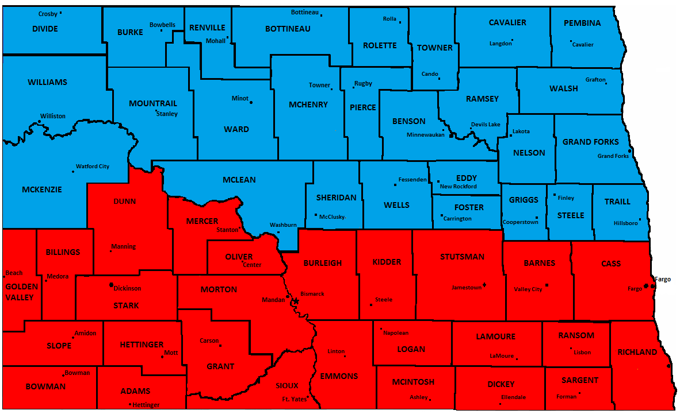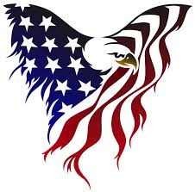

**Kelli Weiand**

**(701) 340-2779**

**(701) 420-5848**

**Nikki Frohlich**

**(701) 260-4730**

**(701) 333-3828**

◻ State and Federal Veterans Benefits

◻ Military Records

◻ Mental Health/PTSD

◻ Homelessness

◻ Retirement

◻ Financial

◻ Employment

◻ Homelessness

The North Dakota Military Outreach Program is a state program designed to assist Military Veterans, Past and Present Service Members, and their Families in finding resources, services, and benefits to meet their needs. Military Outreach Specialists are regionally located throughout North Dakota. They connect you with information and resources in the areas of:

***NORTH DAKOTA***

***MILITARY OUTREACH PROGRAM***

***“Supporting Those Who Served”***